

**DESIGNING AND DEVELOPING A WEBSITE**

**Programming Method**

**Module Title**

**Retail Camping Company**

**Assignment Title**

**Winter 2023**

**Examination Cycle**

**YE HTET WIN**

**Candidate Name**

**P00200860**

**Candidate No**

**KMD Institute (Yangon)**

**Centre Name**

**October 8, 2023**

**Submission Date:**

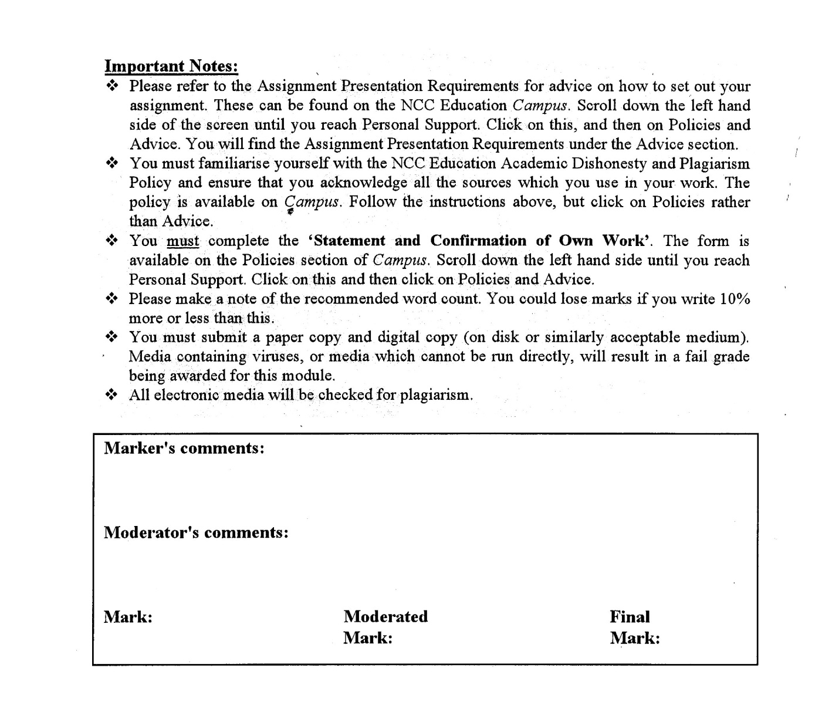



**Statement and Confirmation of Own Work**

**Programme/Qualification name: L4DC**

*All NCC Education assessed assignments submitted by students must have this statement as the cover page or it will not be accepted for marking. Please ensure that this statement is either firmly attached to the cover of the assignment or electronically inserted into the front of the assignment.*

**Student declaration**

I have read and understood NCC Education’s Policy on Academic Dishonesty and Plagiarism.

I can confirm the following details:

**Student ID/Registration number:** **P00200860**

**Name : YE HTET WIN**

**Centre Name : KMD Institute (Yangon)**

**Module Name : DESIGNING AND DEVELOPING A WEBSITE**

**Module Leader : SHAIN THU**

**Number of words : (2100) WORDS**

I confirm that this is my own work and that I have not plagiarised any part of it. I have also noted the assessment criteria and pass mark for assignments.

**Due Date : October 8, 2023**

**Student Signature : Ye**

**Submitted Date : October 8, 2023**

# Table of Contents

Contents

Table of Contents 3

Introduction 4

Task-1 Web Design Screenshot 6

Task-2 CSS 25

Task-3 Test the website and write a test report 26

Using the W3C validation service (http://validator.w3.org/) 26

Accessibility using a screen reader 32

How the website works for disabled Users 35

Testing the website on two browsers 36

Test Report 43

The role of the W3C 43

Task-4 Critical Evaluation 45

(a) Three Different Plugins 45

(b) Two Web Application Development Tools 46

(c) Two Business Benefit to RCC of using web services 47

(d) Improvements for further development 47

References 48

Candidate checklist 49

# Introduction

This assignment is about designing and developing a website that not only indicates RCC's range of products but also provides a smooth and visually appealing user experience. The assignment includes total of 4 tasks;

For Task-1, requirements of each page will be screen shot and explain in both desktop view and mobile view.

For Task-2, the code for the CSS will be provided.

For Task-3, each page will be tested using W3C validation service. If any errors were occurred during testing, the errors will be explained and debugged. And the website will be tested using screen reader. Furthermore, the website will be also tested on two different web browsers for any differences. After all the testing are completed, it will be concluded by writing test report and the role of W3C.

For Task-4, the three different plugins used for the website will be identified and explained. Which will also include explanation of the two web application development tools that were used to develop the website. After this, the two business benefit will be justified and how the website can be further develop will be explained.

**Task 1**

**HTML**

# Task-1 Web Design Screenshot

This website will serve as a resource for camping enthusiasts, displaying a wide range of camping equipment and related product. Hoping to establish an online platform that captivates and informs visitors by focusing on usability, mobile responsiveness, and a modern design. This task sets up the basis for an appealing online camping experience, from the main page to specialized parts like equipment, furniture, cart, offers & packages and customer reviews.

(1) Home Page

Users can see an introduction to camping with **minimal texts** with a gif that was uploaded by using **plug-in** **(object)**. Users can search individual or related products through the **animated search bar** and navigate to the other pages using the **navigation bar** which includes **links to other pages**. There is a **slideshow** showing current sale offers by the company. If the user clicks on the slideshow a **popup** banner will appear, which link to the sales section of the offers and package page if clicked on it. Three **sections** of items are available in home page, best-selling products section, discount packages section and budget packages section. Users can explore more of the sections by clicking their respective **buttons**. There is also an **(iframe)** providing the physical location of the company at the end of the page.

Desktop View of Home Page

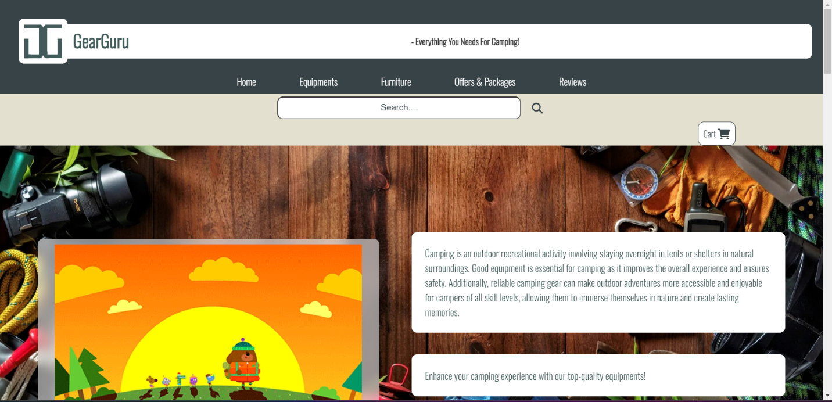

**Fig (Home Page Introduction Desktop View)**

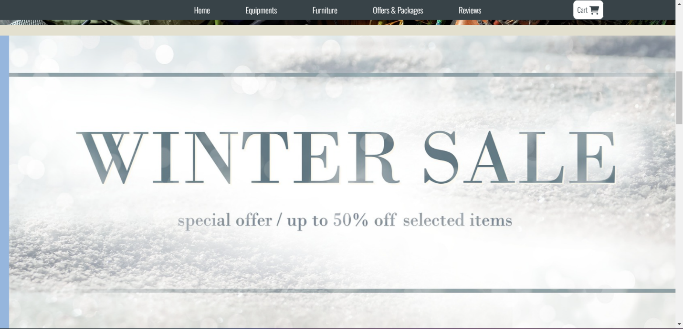

**Fig (Home page’ slideshow desktop view)**

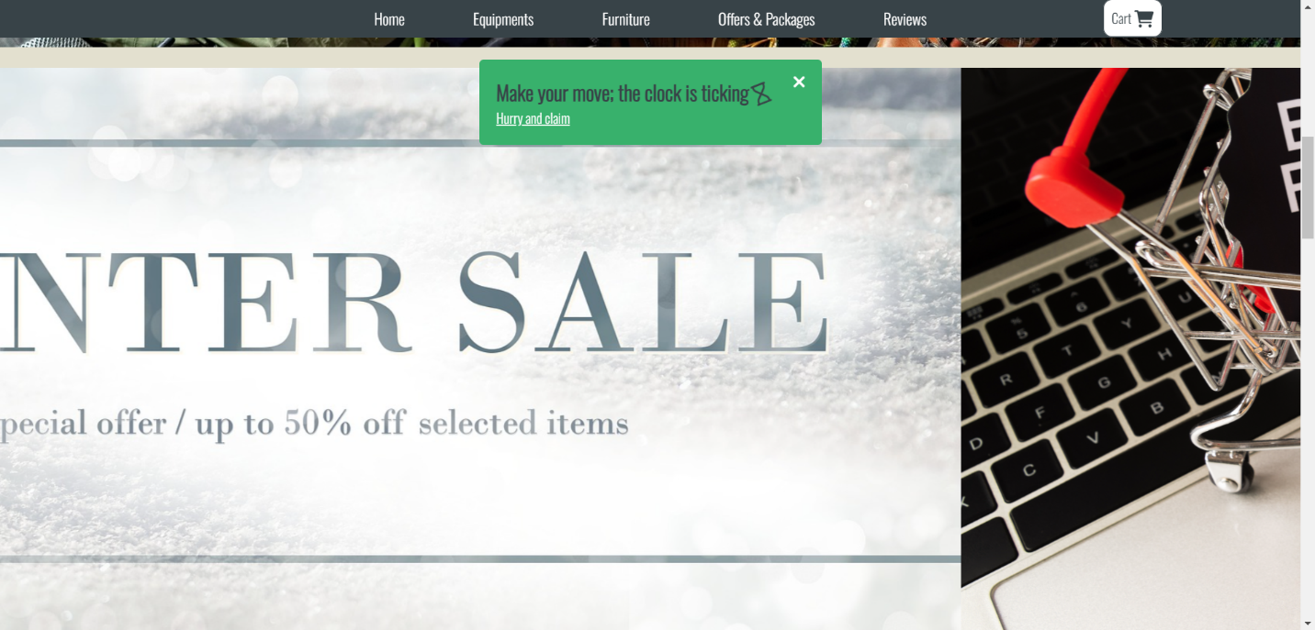

**Fig (Home page’ popup banner Desktop view)**

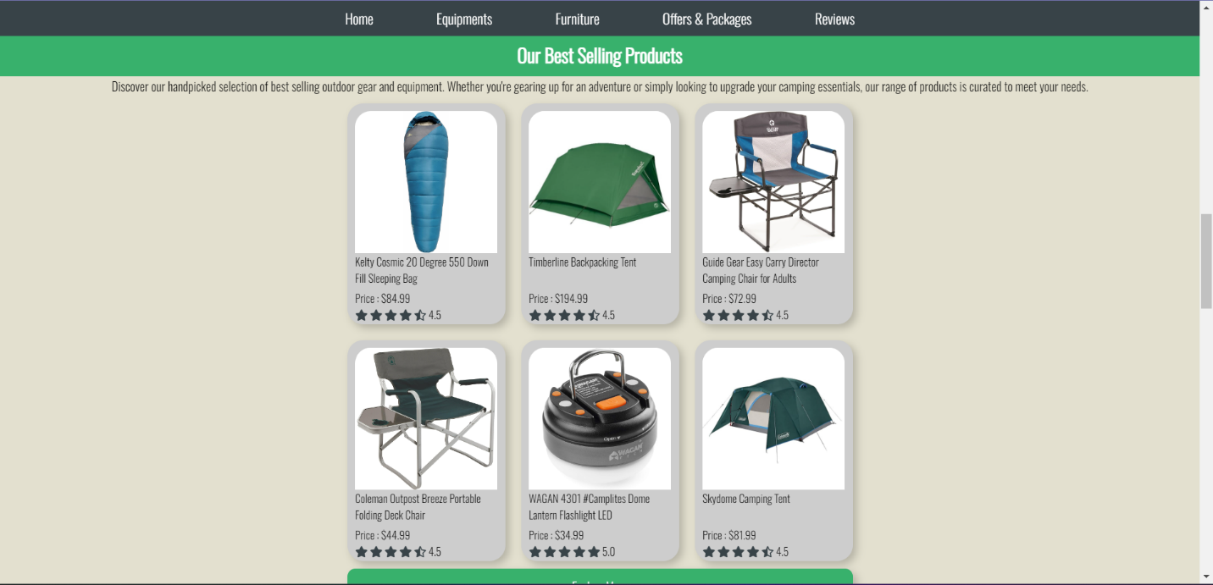

**Fig (Home page best-selling products section)**

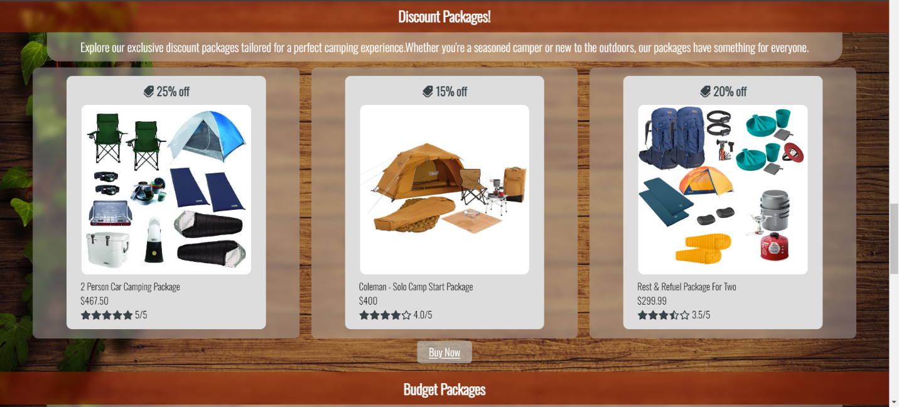

**Fig (Home page’ recommended packages section)**

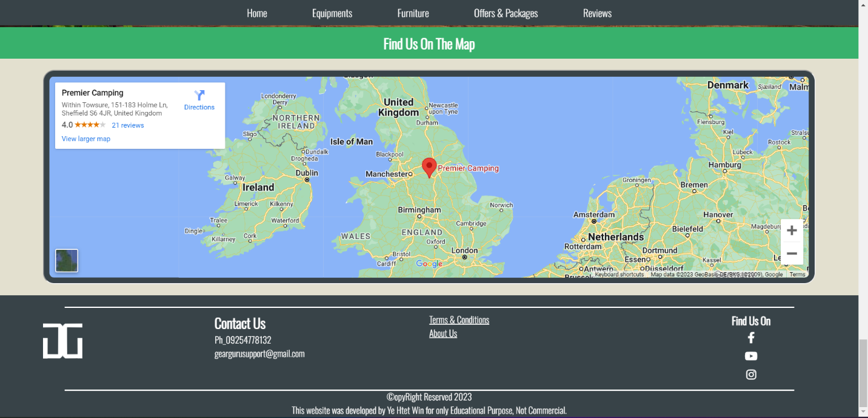

**Fig (Home page <iframe> desktop view**

Mobile Device View of Home Page

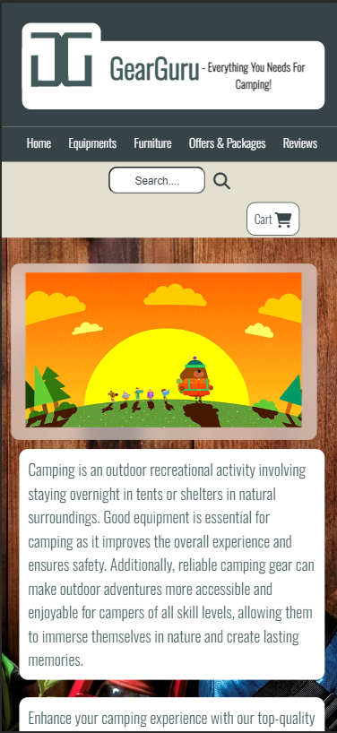 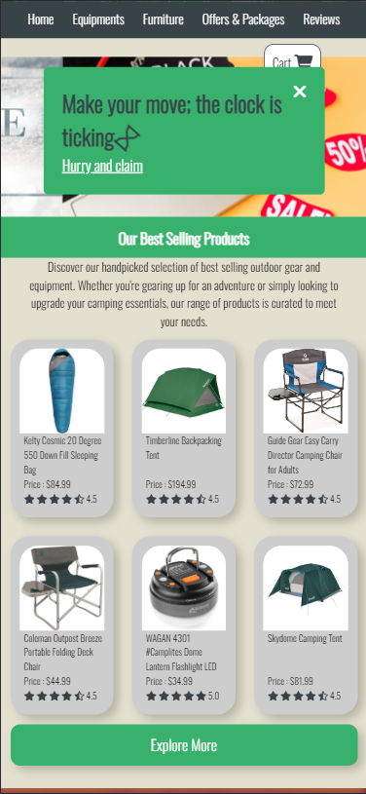 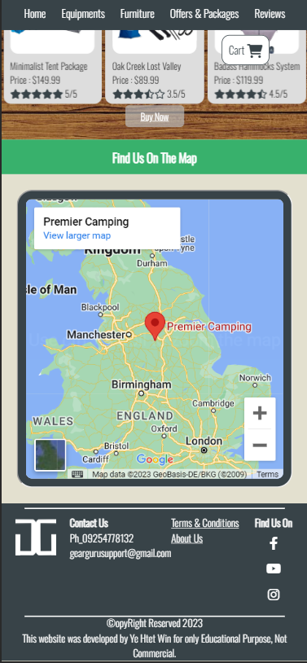

**Fig (Home Page Mobile View)**

(2) Equipment Page

Users can search the equipment using the **animated search bar** and process to other pages through **navigation bar**. Users can go through **equipment category** by using **Category options** instead of scrolling all the way to each item. Users can add the item to the cart by clicking “add to cart” on item card. After adding, customers can see added items in cart container. The cart will slide down and show the added items when clicked on it. Users can process to cart page by clicking “My Cart” button in cart container. Users will see the current sale equipment of the company and the sections of equipment. When users put the cursor on an item, the details label will show up. When details label is clicked, the detail container will pop up and show the details of the clicked item. At the end of the page, there is an **(iframe)** **plug-in**, providing a video of essential equipment recommended for camping.

Desktop view of Equipment Page

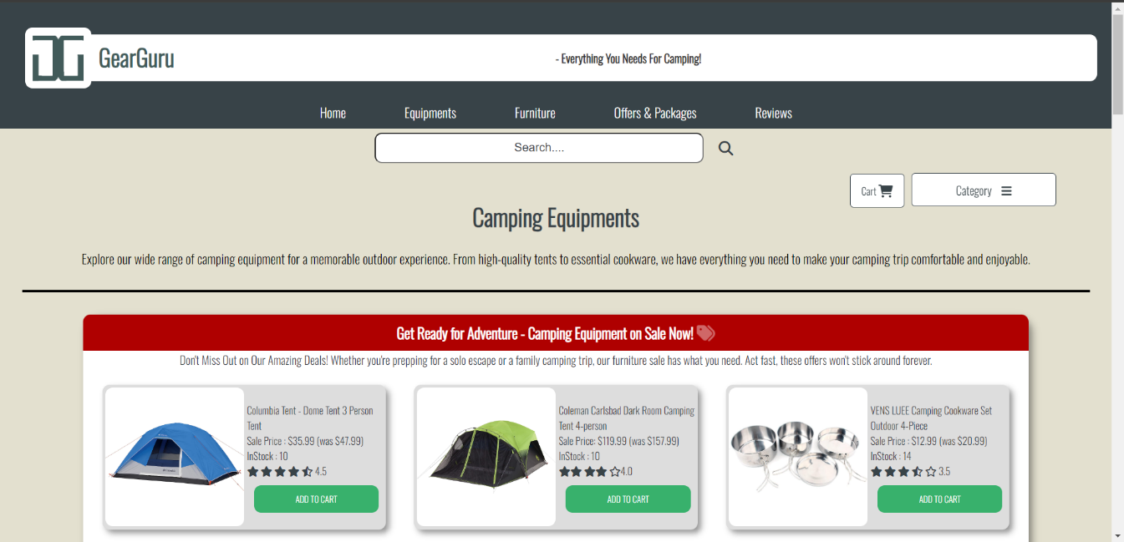

**Fig (Equipment Page Desktop View)**

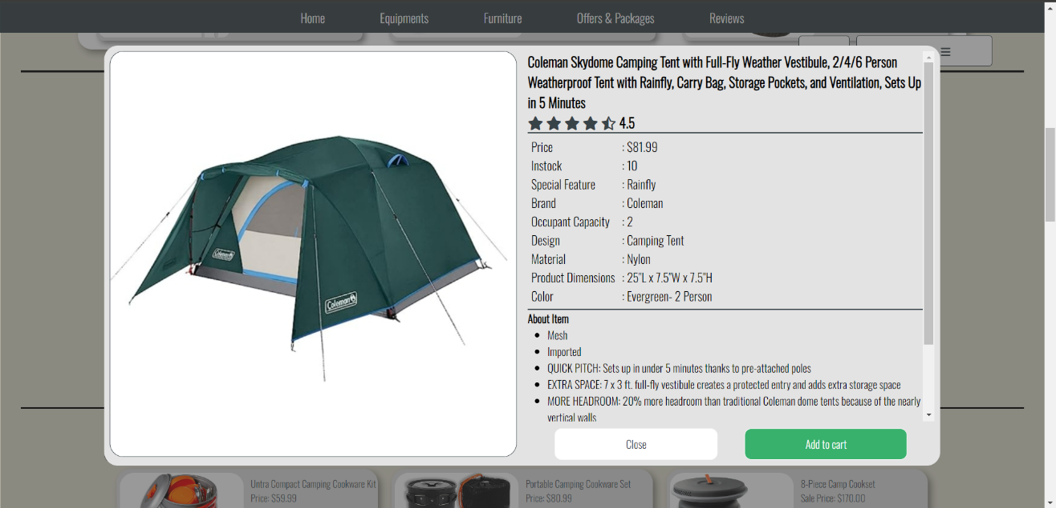

**Fig (Equipment Pop up Details Desktop View)**

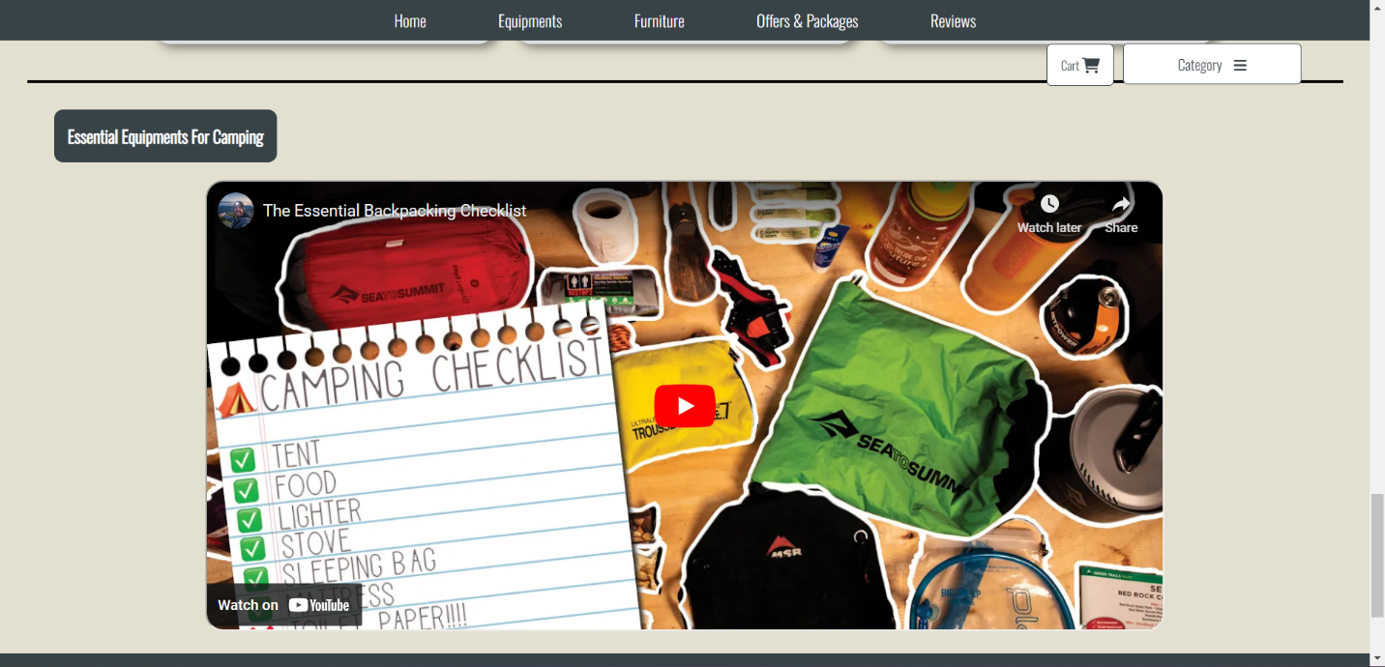

**Fig (Equipment page’ (iframe) desktop view**

Mobile View of Equipment Page

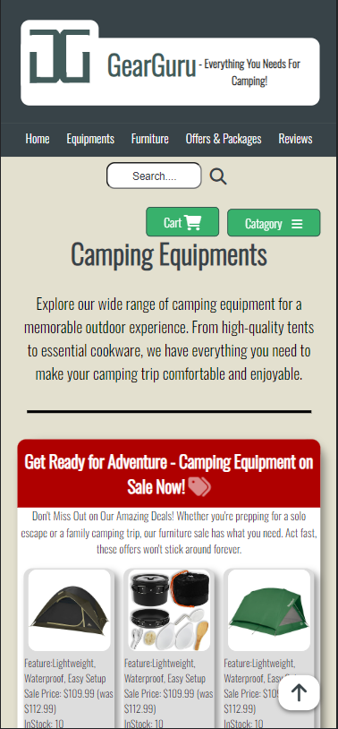 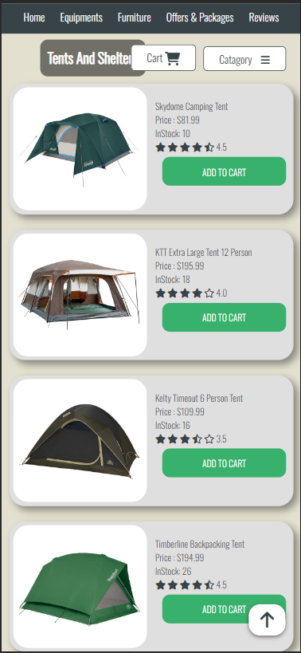 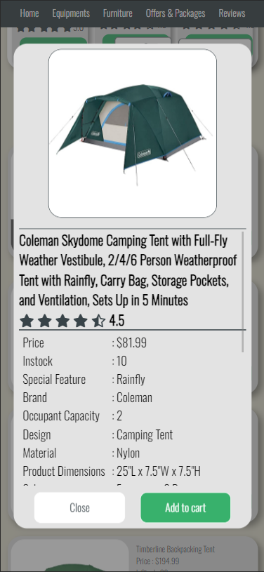

**Fig (Equipment Page Mobile View)**

(3) Furniture Page

Furniture Page serves the same as the equipment page but with the camping furniture instead of equipment. At the end of the furniture page, there is an **(iframe) plug-in**, providing video of essential furniture recommended for camping.

Desktop View of Furniture Page

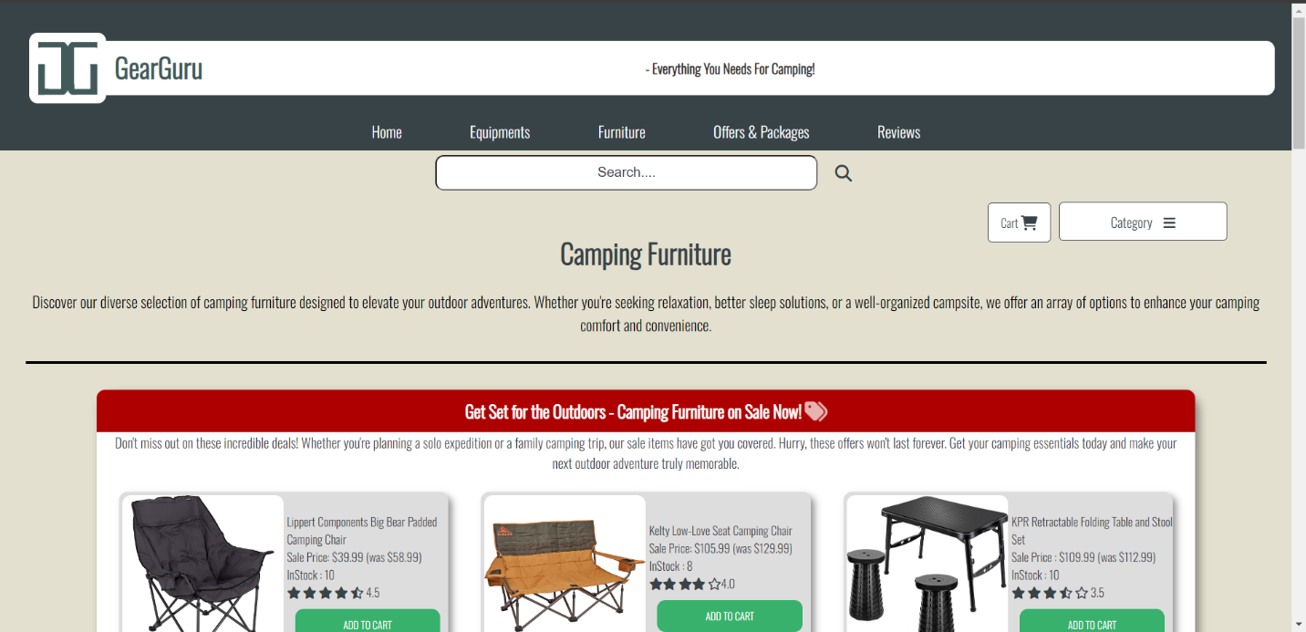

**Fig (Furniture Page Desktop View)**

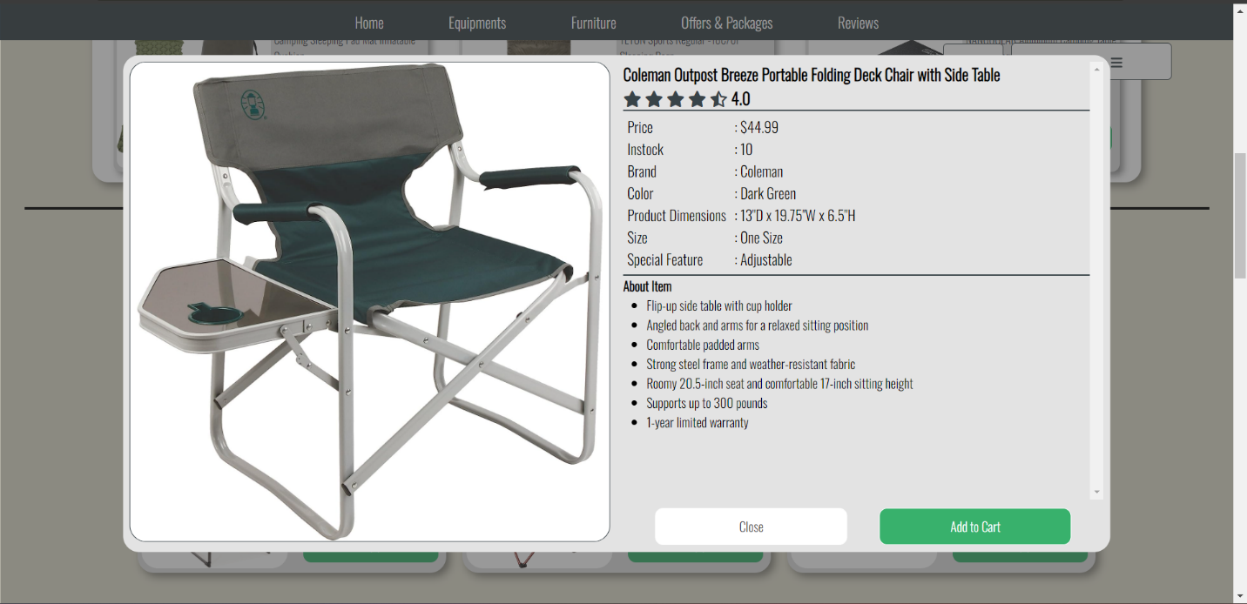

**Fig (Pop up Furniture Details Desktop View)**

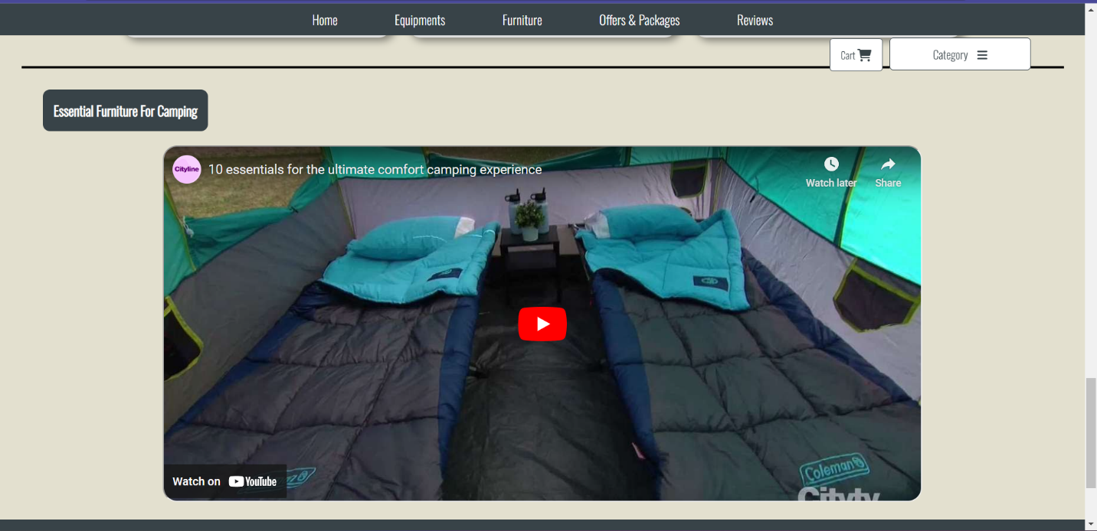

**Fig (Furniture page’ (iframe) desktop view)**

**Mobile View of Furniture Page**

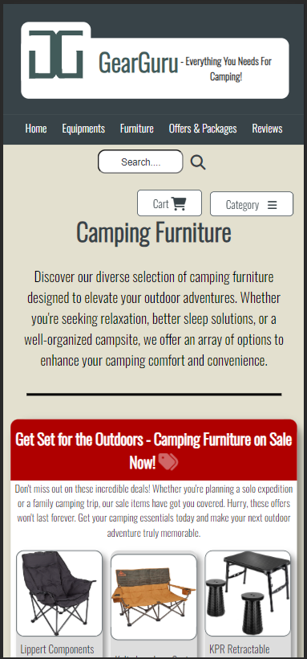 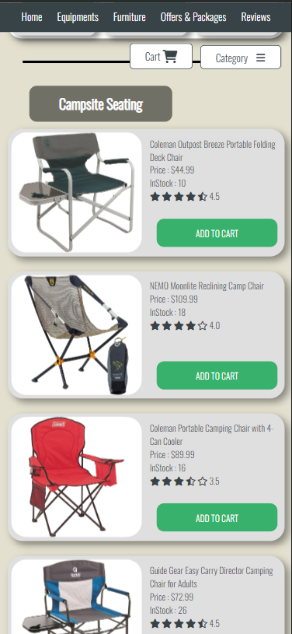 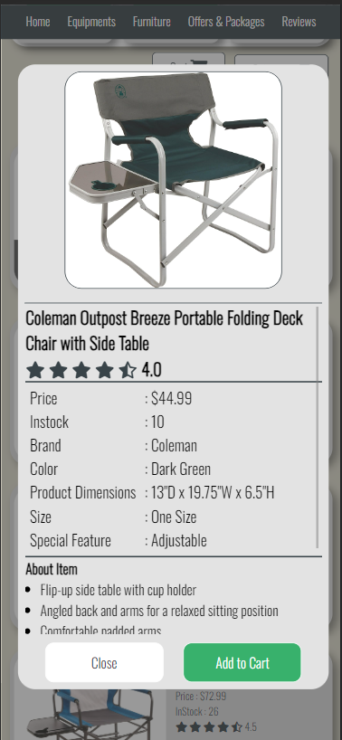

**Fig (Furniture Page Mobile View)**

**(4) Offers & Packages Page**

Users can search items using **animated search bar** also in offers & packages page. Users will see section of **current sale items and the packages** and other packages such as starter packages and budget packages. Just like in equipment page and furniture page, when users click on the “Details” label, the details of the item will pop up.

**Desktop View of Offers & Packages Page**

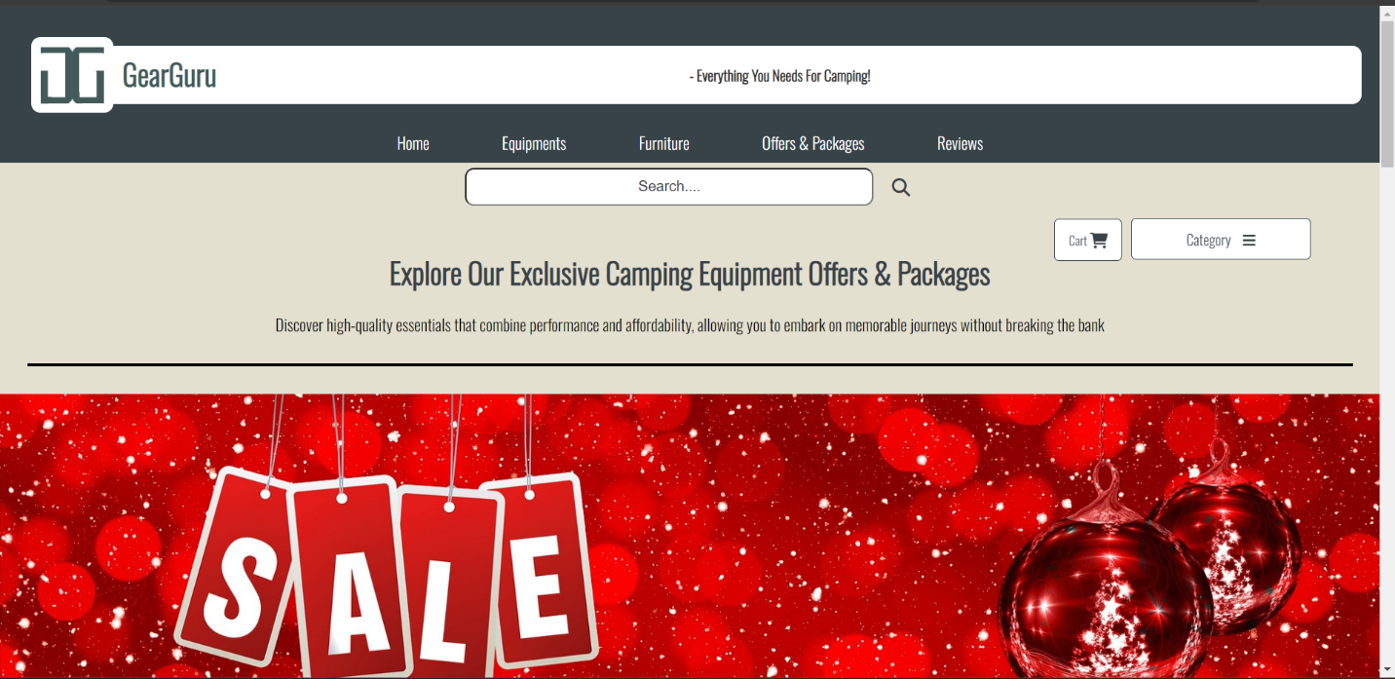

**Fig (Offers & Packages Desktop View)**

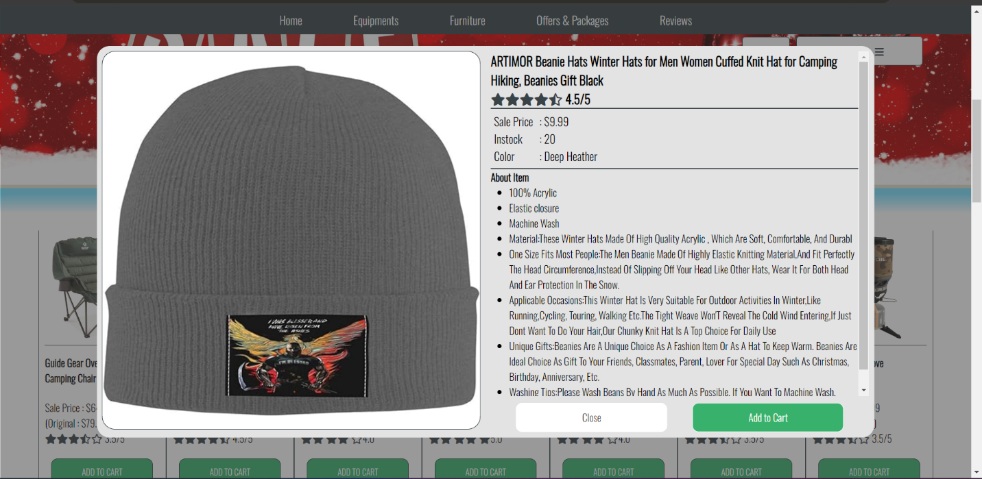

**Fig (Offers & Packages Page Item Details Pop Up)**

**Mobile View of Offers & Packages Page**

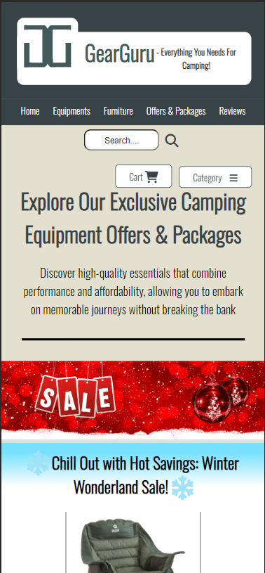 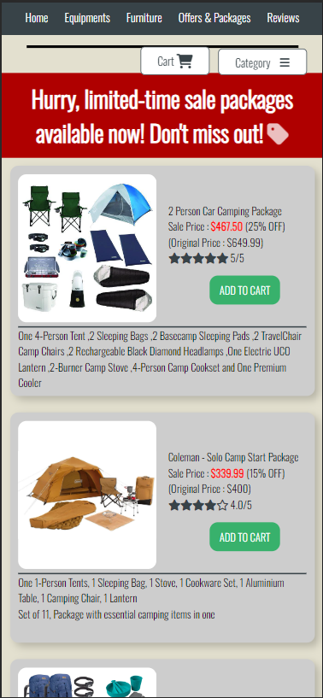 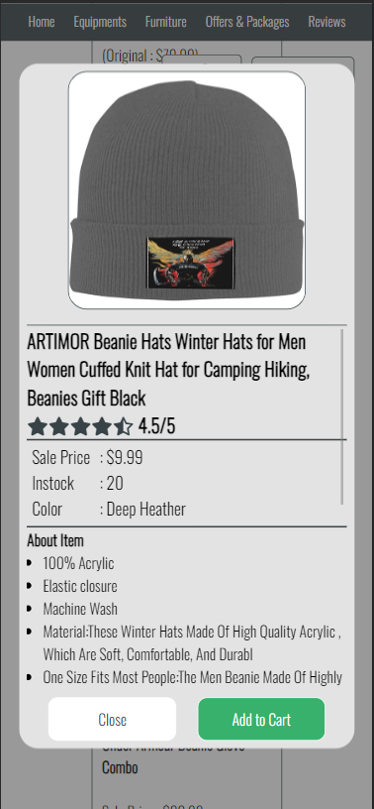

**Fig (Offers & Packages Mobile View)**

**(5) Cart Page (Basket Page)**

User can **add more or remove items** from the cart and use the coupon to get a discount. The user will need to fill out the payment requirement to process the **checkout**. Or the users can go back to shopping by clicking “Continue Shopping” button.

**Desktop View of Offers & Packages Page**

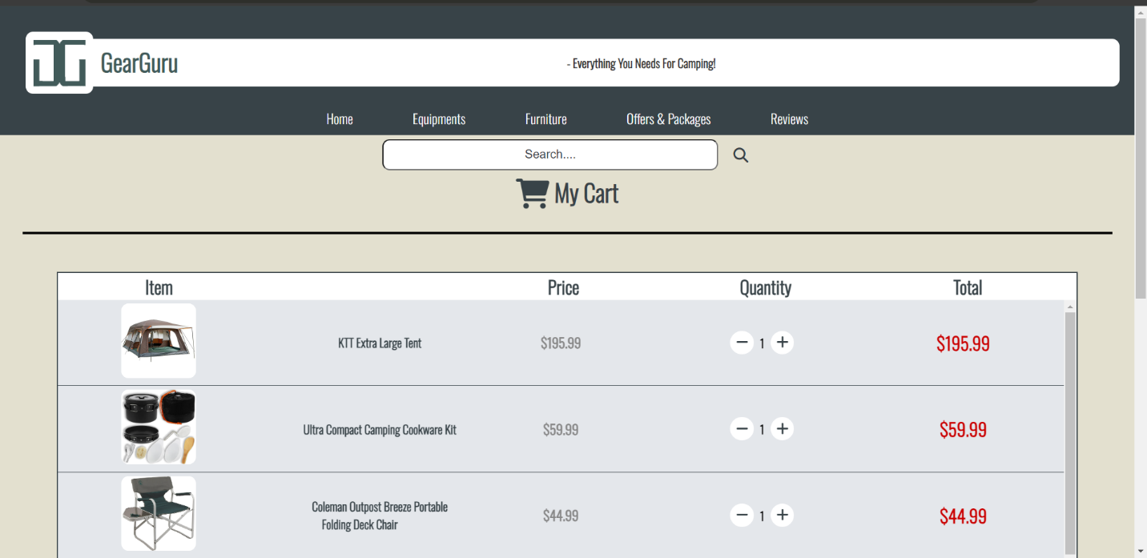

**Fig (Upper Cart Page Desktop View)**

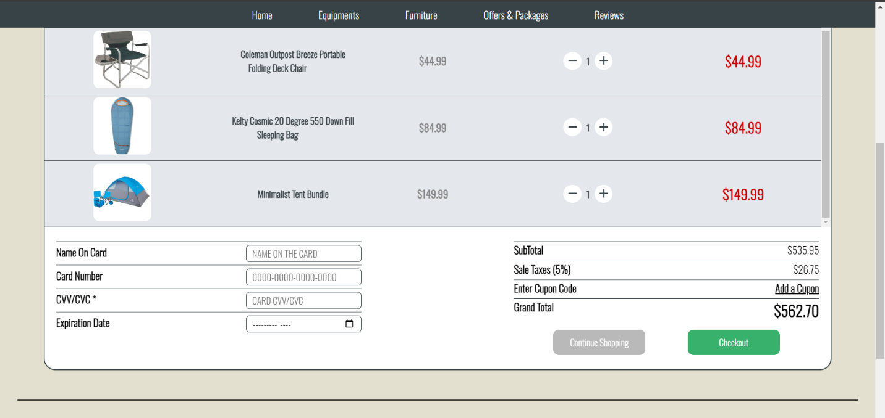

**Fig (Lower Cart Page Desktop View)**

**Mobile View of Cart Page**

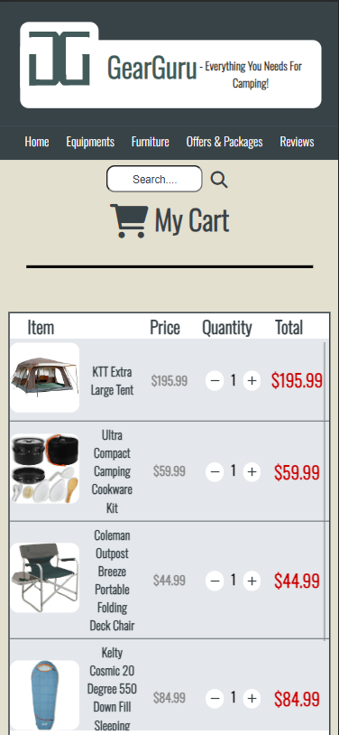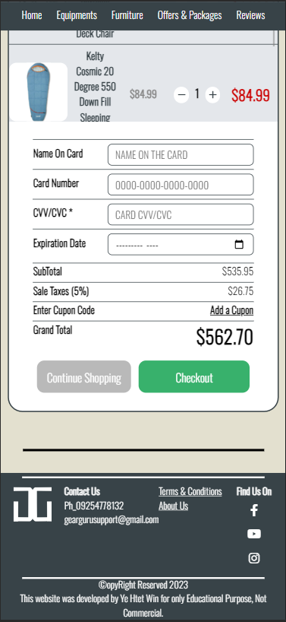

**Fig (Cart Page Mobile View)**

**(6) Review Page**

Users can read the reviews left by other customers in review page and **write a new review** by clicking the “Write a Review” button at the bottom of the display. The “Write a Review” division is stick at the bottom of the display. After clicking the button, the review form will pop up. In the review form, users can rate and upload the picture of the item. To submit the from, the users will need to fill the review content of the item, and their **first name, last name** and **email** to **register**. Though there is an option to upload the picture, it is not necessary needed to write a review. If the picture is not uploaded, the review card will display “IMAGE NOT AVALIABLE” text instead of the item’ picture.

**Desktop View of Review Page**

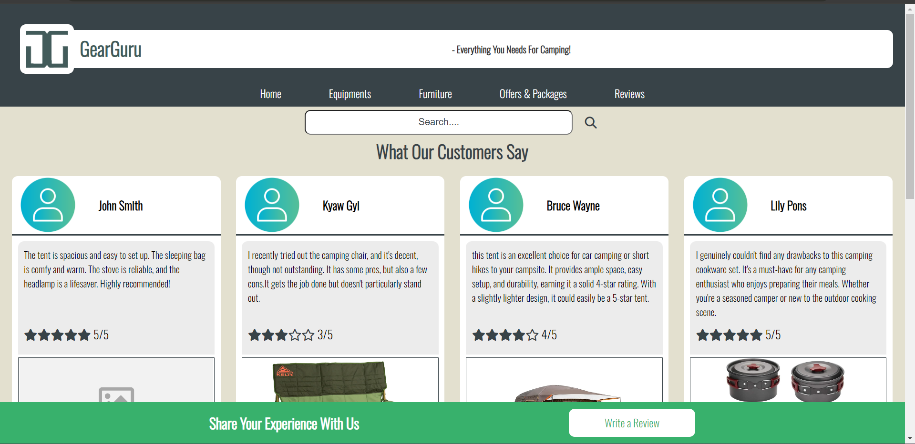

**Fig (Review Page Desktop View)**

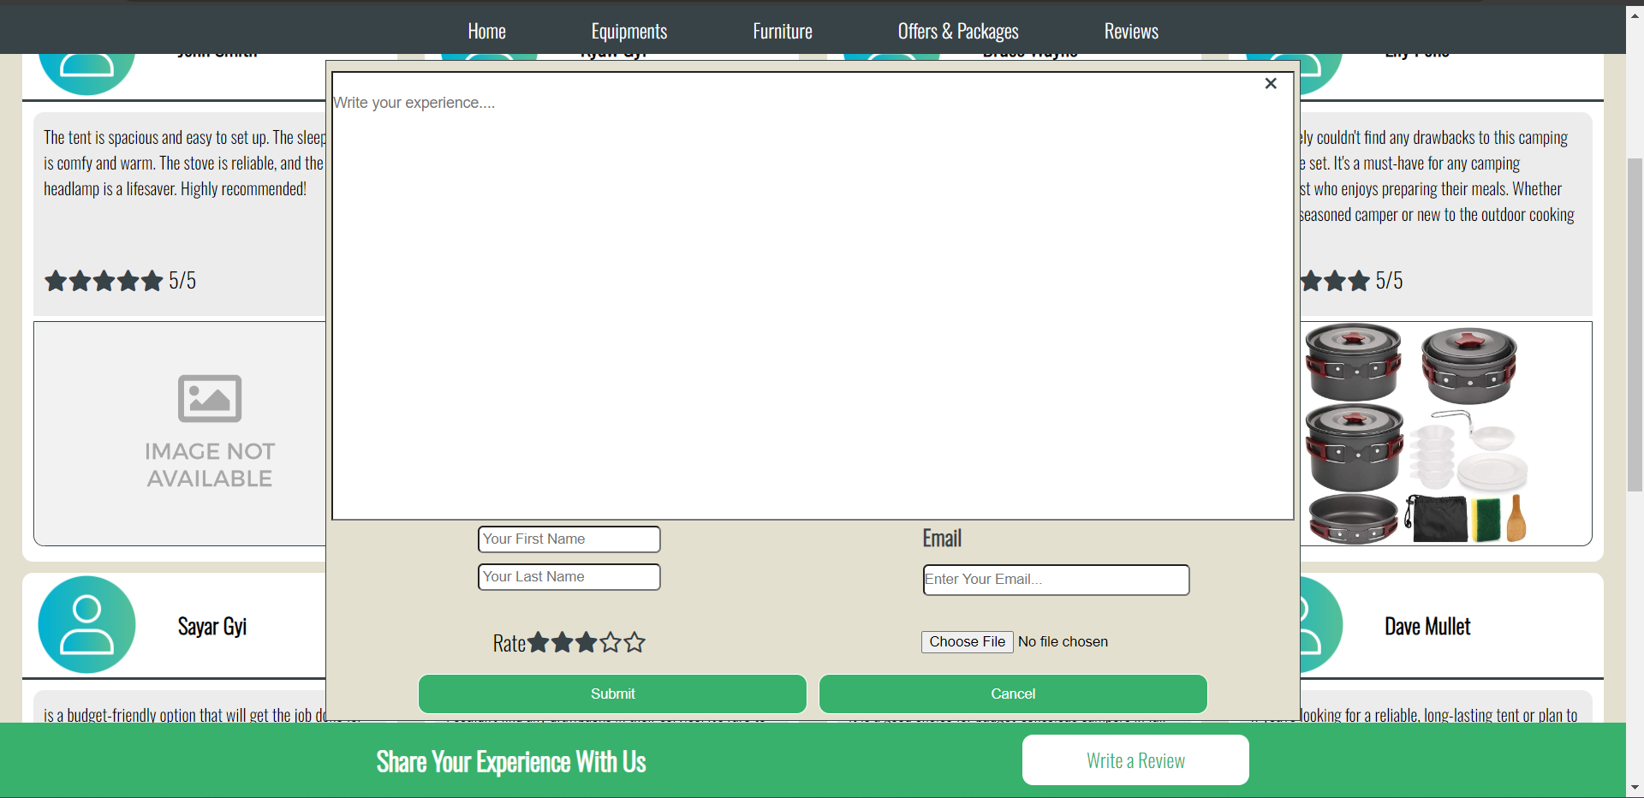

**Fig (Pop Up Review Form Desktop View)**

**Mobile View of Review Page**

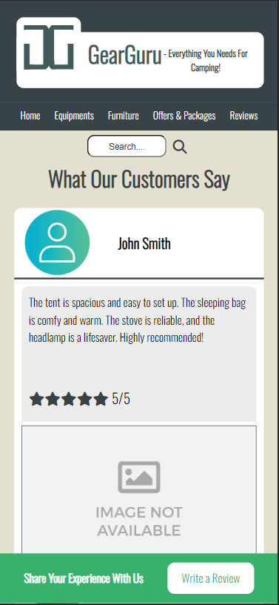 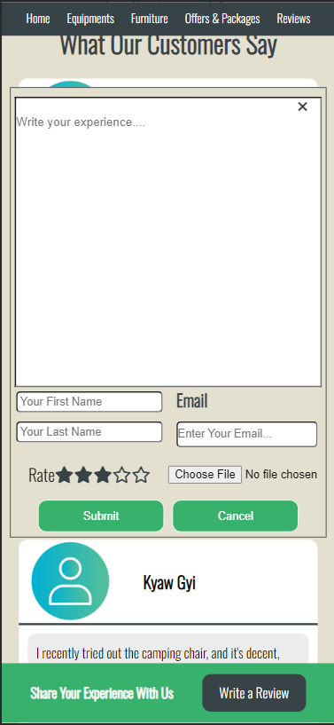

**Fig (Review Page Mobile View)**

**Task 2**

**CSS**

# Task-2 CSS

CSS, or cascading style sheets, explains how HTML components should appear on a screen, in paper, or in other media. A lot of work is saved using CSS. It can manage the design of several web pages simultaneously. In CSS files, external stylesheets are maintained. (W3Schools, 2023)

For the RCC’ website, ‘**box-sizing: border-box**’ are used to simplify layout and design of the website in CSS. **‘display: flex; flex-wrap: wrap;’** are used to create a flexible layout using the CSS Flexbox model. Margin, padding, width, height and font size are properly adjusted to make the website enjoyable and engaging. **‘object-fit: contain’** were used to make the images’ ratio of the website display properly. **‘transition: transform second’** were used to make the clicking buttons smoother.

* {

    box-sizing: border-box;

    margin: 0px;

    padding: 0;

}

body {

    position: relative;

    font-family: 'Oswald', sans-serif;

    margin: 0;

    padding: 0;

    background-color: #E3E0CF;

    cursor: default;

}

header {

    padding: 20px;

    text-align: center;

    background-color: #384348;

}

header img {

    float: left;

    width: 90px;

    border-radius: 10px;

    padding: 10px;

    margin-top: 1%;

    margin-left: 1%;

    background-color: white;

}

header h1 {

    color: #425B5A;

    background-color: white;

    float: left;

    margin-top: 30px;

    margin-left: 10px;

}

header p {

    font-weight: bold;

    margin-left: 1%;

    padding: 20px;

    color: #333333;

    background-color: white;

    border-radius: 10px;

}

footer {

    padding-top: 20px;

    background-color: #384348;

}

.footer-upper-container {

    display: flex;

    align-items: flex-start;

    text-align: left;

    justify-content: space-evenly;

    margin: 10px 0 10px 0;

}

footer p {

    color: white;

}

.contactus h2 {

    color: #ffffff;

}

.contactus ul {

    color: #ffffff;

    display: flex;

    flex-direction: column;

    list-style: none;

}

ul.footer-middle-col {

    list-style: none;

}

ul.footer-middle-col a {

    color: #ffffff;

}

.footer-group {

    flex: 20%;

}

.footer-group h3 {

    color: #ffffff;

}

.footer-group img {

    margin-top: 5%;

    margin-left: 20%;

    width: 70px;

}

.footer-icons-container {

    display: flex;

    flex-direction: column;

    align-items: center;

}

.footer-icons-container a {

    margin: 3px;

}

.footer-icons-container i {

    color: #ffffff;

    padding: 13px 6px 13px 6px;

    border-radius: 3px;

    transition: 0.4s background-color, 0.6s color;

}

.footer-icons-container i:hover {

    color: #38b16c;

    background-color: #ffffff;

}

.footer-br {

    height: 2px;

    background-color: #ffffff;

    width: 85%;

    position: absolute;

    left: 50%;

    transform: translateX(-50%);

}

.footer-under-p {

    text-align: center;

}

/* ...............rating-star............ */

.fa-solid.fa-star,

.fa-regular.fa-star-half-stroke,

.fa-regular.fa-star {

    color: #384348;

}

/* ..............navigation-bar............ */

nav {

    display: flex;

    background-color: #384348;

    top: 0;

    z-index: 10;

    height: 45px;

    position: sticky;

    align-items: center;

    justify-content: center;

}

.nav-bar ul {

    list-style: none;

    display: flex;

}

.nav-bar li {

    margin: 0 30px;

}

.nav-bar li a {

    padding: 3px 10px;

    transition: 0.3s ease-in-out;

    font-size: 18px;

    color: #ffffff;

    text-decoration: none;

    border-radius: 5px;

}

.nav-bar li a:hover {

    cursor: pointer;

    background-color: #38b16c;

}

.float-container {

    margin-top: 20px;

    right: 5%;

    float: right;

    display: flex;

    align-items: center;

    position: sticky;

    top: 8%;

    z-index: 10;

}

/* .............MiniCart............... */

.cart-container {

    margin-top: 10px;

    position: absolute;

    width: 450px;

    overflow: hidden;

    max-height: 0;

    height: 0;

    margin-top: 8px;

    right: 0.1%;

    border-radius: 10px;

    background-color: #ffffff;

    transition: height 0.3s;

}

.cart-toggle:checked~.cart-container {

    border: 1px solid black;

    max-height: unset;

    height: 400px;

}

label.shopping-cart {

    cursor: pointer;

    font-size: 14px;

    color: #384348;

    background-color: #ffffff;

    padding: 12px 15px;

    border-radius: 5px;

    margin: 0;

    transition: 0.3s;

    border: 1px solid #384348;

}

label.shopping-cart:hover {

    background-color: #384348;

    color: #ffffff;

}

.cart-product-container {

    height: 300px;

    overflow-y: scroll;

    background-color: #eeeeee;

}

.cart-product {

    display: flex;

    align-items: center;

    justify-content: space-between;

    border-bottom: 1px solid #384348;

}

.cart-product img {

    width: 100px;

    height: auto;

    aspect-ratio: 1/1;

    margin: 5px;

    border-radius: 10px;

    object-fit: contain;

    background-color: #ffffff;

}

.count {

    margin: 0 5px;

    font-weight: bold;

}

.cart-product-quantity i {

    padding: 10px 5px;

    background-color: #cdcdcd;

    border-radius: 50%;

    color: #384348;

    cursor: pointer;

    transition: 0.3s;

}

.cart-product-quantity i:hover {

    background-color: #ffffff;

    color: #af0000;

}

.cart-product-details {

    text-align: center;

}

p.cart-product-name {

    width: 100px;

    color: #384348;

    font-weight: bold;

    word-wrap: break-word;

}

p.cart-product-price {

    color: #af0000;

}

.cart-product button {

    padding: 10px 15px;

    margin-right: 1%;

    border: none;

    background-color: #9e0000;

    color: #ffffff;

    border-radius: 5px;

    cursor: pointer;

    transition: 0.3s;

}

.cart-product button:hover {

    background-color: #ffffff;

    color: #ff0000;

}

.cart-checkout {

    background-color: #384348;

    display: flex;

    justify-content: space-evenly;

    align-items: center;

    height: 98px;

}

.cart-total {

    display: flex;

    align-items: end;

}

p.p-total {

    color: #ffffff;

    font-size: 20px;

}

p.cart-total-price {

    color: #ffffff;

    font-size: 26px;

    font-weight: bold;

    margin-left: 5px;

}

.cart-checkout a {

    font-size: 20px;

    padding: 10px 20px;

    border: 1px solid #ffffff;

    background-color: #ffffff;

    color: #384348;

    border-radius: 10px;

    cursor: pointer;

    transition: 0.4s;

    text-decoration: none;

}

.cart-checkout a:hover {

    background-color: #38b16c;

    color: #ffffff;

}

.cart-toggle {

    opacity: 0;

}

/* ..................menu-button............... */

#toggle {

    display: none;

}

.menu-button {

    border: 1px solid #384348;

    border-radius: 5px;

    color: #384348;

    background-color: #ffffff;

    padding: 10px 60px;

    cursor: pointer;

    z-index: 1;

    transition: 0.4s;

    margin-left: 10px;

}

.menu-button:hover {

    color: #ffffff;

    background-color: #384348;

}

.dropdown-menu {

    display: none;

    position: absolute;

    margin-top: 10px;

    width: 197px;

    right: 0;

    background-color: #f2f2f2;

    z-index: 1;

    border: 1px solid #384348;

    border-radius: 0 0 10px 10px;

    transition: height 0.4s ease-in-out;

}

#toggle:checked~.dropdown-menu {

    display: block;

}

.dropdown-menu a {

    display: block;

    padding: 12px 16px;

    text-decoration: none;

    color: #384348;

    transition: 0.3s color, 0.5s background-color;

}

.dropdown-menu a:hover {

    color: #ffffff;

    background-color: #38b16c;

}

a.menu-last-row:hover {

    border-radius: 0 0 10px 10px;

}

/* .............Cart............ */

h1.cart-h1 {

    text-align: center;

    color: #384348;

}

.cart-page {

    text-align: center;

    display: flex;

    justify-content: center;

}

.cart-page-container {

    margin: 20px 0;

    border: 2px solid #384348;

    border-radius: 0 0 20px 20px;

    width: 90%;

    background-color: #ffffff;

}

.cart-page-item-title-row {

    display: flex;

    margin-right: 10px;

}

.cart-page-desc-title {

    font-weight: bold;

    font-size: 24px;

    color: #384348;

    width: 20%;

}

.cart-page-row-container {

    height: 450px;

    overflow-y: scroll;

    background-color: #e4e7eb;

    justify-content: space-between;

}

.cart-page-item-row {

    display: flex;

    text-align: center;

    align-items: center;

    border-bottom: 0.5px solid #384348;

    padding: 5px 0;

}

.cart-page-item-col {

    width: 20%;

}

.cart-page-item-col img {

    width: 100px;

    height: auto;

    aspect-ratio: 1/1;

    background-color: #ffffff;

    border-radius: 10px;

    object-fit: contain;

}

.cart-page-item-name {

    word-wrap: break-word;

    margin-left: 20%;

    font-weight: bold;

    font-size: 16px;

    color: #384348;

}

.cart-page-item-quantity i {

    cursor: pointer;

    padding: 15px 8px;

    font-size: 18px;

    background-color: #ffffff;

    color: #384348;

    border-radius: 20px;

    transition: 0.3s ease-in-out;

}

.cart-page-item-quantity i:hover {

    background-color: #38b16c;

    color: #ffffff;

}

.cart-page-price {

    font-weight: bold;

    font-size: 18px;

    color: #878787;

}

.quantity {

    margin: 0 5px;

    font-weight: bold;

}

.cart-page-total {

    font-weight: bold;

    color: #cb0000;

    font-size: 24px;

}

.total {

    display: flex;

    justify-content: space-between;

    padding: 20px;

    transition: 0.3s;

}

.total-col {

    width: 40%;

}

.total-1st-col-row {

    display: flex;

    justify-content: space-between;

    margin: 5px 0;

    border-top: 1px solid #384348;

    font-size: 18px;

    font-weight: bold;

    align-items: center;

}

.total-1st-col-row input {

    text-align: left;

    margin-top: 5px;

    width: 200px;

    padding: 10px;

    height: 30px;

    font-family: 'Oswald', sans-serif;

    font-size: 16px;

    border-radius: 6px;

    border: 1px solid #384348;

}

.total-row {

    margin: 5px 0;

    display: flex;

    border-top: 1px solid #384348;

    justify-content: space-between;

    font-size: 18px;

    font-weight: bold;

}

.total-row-right-col {

    font-weight: normal;

}

.total-row-grand {

    font-size: 26px;

}

.total-row a {

    color: #384348;

    font-weight: normal;

}

.cupon-container {

    display: grid;

    text-align: right;

}

.cupon-container label {

    text-decoration: underline;

    cursor: pointer;

}

.cupon-container input {

    max-height: 0;

    border: none;

    border-radius: 5px;

    transition: 0.5s;

}

#cupon:focus {

    max-height: 100px;

    padding: 7px 20px;

}

.cart-page-checkout {

    margin-top: 10px;

    display: flex;

    justify-content: space-evenly;

}

.cart-page-checkout button {

    border-radius: 10px;

    width: 160px;

    padding: 10px;

    background-color: #38b16c;

    color: #ffffff;

    transition: 0.3s ease-in-out;

    cursor: pointer;

    font-family: 'Oswald', sans-serif;

    border: none;

    font-size: 16px;

    margin: 5px;

}

.cart-page-checkout a {

    color: #ffffff;

    text-decoration: none;

    width: 160px;

    padding: 10px;

    border-radius: 10px;

    background-color: #b9b9b9;

    cursor: pointer;

    margin: 5px;

}

.cart-page-checkout a:hover,

.cart-page-checkout button:hover {

    background-color: #384348;

}

/* .................search bar................... */

.input-search {

    display: flex;

    align-items: center;

    padding: 5px 10px;

    justify-content: center;

    border-radius: 10px;

}

.input-search input {

    width: 30%;

    border-radius: 10px;

    padding: 10px;

    font-size: 16px;

    background-color: #ffffff;

    text-align: center;

    transition: 0.3s linear;

}

.input-search input:focus {

    width: 90%;

}

.input-search ::placeholder {

    font-size: 16px;

    color: #384348;

}

.search-button {

    margin-left: 1%;

    padding: 5px;

    border-radius: 10px;

    color: #384348;

    cursor: pointer;

    transition: 0.3s;

}

.search-button:hover {

    color: #ffffff;

    background-color: #38b16c;

}

/* ............home.............. */

.home-cart {

    position: sticky;

    float: right;

    top: 0;

    z-index: 10;

    margin-right: 10%;

    padding: 10px;

}

.home-cart a {

    text-decoration: none;

    background-color: #ffffff;

    color: #384348;

    padding: 9px;

    border: 1px solid #384348;

    border-radius: 10px;

    cursor: pointer;

    transition: 0.3s;

}

.home-cart a:hover {

    color: #ffffff;

    background-color: #384348;

}

.row {

    position: relative;

    display: flex;

    flex-wrap: wrap;

    justify-content: center;

    align-items: center;

    background-image: url(images/camp-gear.jpg);

    background-size: cover;

    background-position: center;

    background-attachment: fixed;

    padding: 160px 10px;

    height: auto;

    width: 100%;

    transition: 0.4s ease-in-out;

}

.column {

    width: 700px;

}

.column-object-container {

    width: 90%;

    height: auto;

    padding: 10px 0;

    background-color: rgba(255, 255, 255, 0.551);

    backdrop-filter: blur(10px);

    border-radius: 10px;

    text-align: center;

    margin: 10px;

}

.column-object-container object {

    width: 90%;

}

.column p {

    margin-right: 10px;

    margin-bottom: 40px;

    font-size: 18px;

    color: #425B5A;

    background-color: white;

    padding: 25px;

    border-radius: 10px;

}

.column a {

    background-color: #38b16c;

    color: #ffffff;

    text-decoration: none;

    padding: 15px;

    margin-left: 43%;

    border-radius: 10px;

    transition: 0.4s;

}

.column a:hover {

    background-color: #ffffff;

    color: #38b16c;

}

.home-overlay {

    z-index: 100;

    position: fixed;

    top: 0;

    bottom: 0;

    left: 0;

    right: 0;

    visibility: hidden;

}

.home-overlay:target {

    visibility: visible;

}

.popup2 {

    margin: 70px auto;

    color: #384348;

    padding: 20px;

    background-color: #38b16c;

    border-radius: 5px;

    width: 400px;

    position: relative;

}

.popup2 a {

    color: #ffffff;

    font-weight: normal;

}

.popup2 a:hover {

    color: #cdcdcd;

}

.popup2 .close {

    top: 10px;

    right: 20px;

    font-size: 20px;

    position: absolute;

    color: #ffffff;

    text-decoration: none;

}

.popup2 .close:hover {

    color: gray;

}

.hurry {

    color: #384348;

    font-weight: bold;

}

.slideshow {

    width: 100%;

    height: auto;

    overflow: hidden;

}

.wrapper {

    display: flex;

    animation: slide 5s infinite;

}

.wrapper img {

    width: 100%;

    object-fit: cover;

    object-position: center;

}

@keyframes slide {

    0%

    /*is for starting position*/

        {

        transform: translateX(0);

        /*work start*/

    }

    25% {

        transform: translateX(-50%);

        /*work start*/

    }

    50% {

        transform: translateX(-100%);

        /*work start*/

    }

    75% {

        transform: translateX(-150%);

        /*work start*/

    }

    100% {

        transform: translateX(-200%);

    }

}

.bestselling-products h2 {

    text-align: center;

    color: #ffffff;

    background-color: #38b16c;

    padding: 10px;

}

.bestselling-products p {

    text-align: center;

    margin-left: 25px;

    margin-right: 25px;

}

.bestselling-row-container {

    display: grid;

    justify-content: center;

}

.bestselling-row {

    display: flex;

    width: 100%;

}

.bestselling-row-container a {

    text-decoration: none;

    background-color: #38b16c;

    color: #ffffff;

    text-align: center;

    padding: 10px;

    margin: 0 10px;

    border-radius: 10px;

    box-shadow: 5px 5px 10px rgba(0, 0, 0, 0.201);

    transition: 0.3s;

    cursor: pointer;

}

.bestselling-row-container a:hover {

    background-color: #384348;

}

.bestselling-col {

    width: 200px;

    height: auto;

    display: grid;

    padding: 10px;

    background-color: rgb(205, 205, 205);

    border-radius: 20px;

    justify-content: center;

    margin: 10px;

    box-shadow: 5px 5px 10px rgba(0, 0, 0, 0.201);

    cursor: pointer;

    transition: 0.3s;

}

.bestselling-col:hover {

    transform: translateY(-10px);

}

.bestselling-col ul {

    list-style: none;

    text-align: left;

    font-size: 14px;

    height: 80px;

}

.bestselling-first-li {

    height: 58%;

}

.bestselling-col img {

    object-fit: contain;

    background-color: #ffffff;

    border-radius: 20px 20px 0 0;

    width: 100%;

    height: auto;

    aspect-ratio: 1/1;

}

.equipments {

    background-image: url(images/wood-panel.jpg);

    background-attachment: fixed;

    background-position: center;

    background-size: cover;

    text-align: center;

    padding-bottom: 20px;

}

.equipments h2 {

    background-color: #a01d0076;

    backdrop-filter: blur(5px);

    padding: 10px;

    color: white;

}

p.packages-intro {

    margin: 0 80px;

    padding: 10px;

    border-radius: 0 0 20px 20px;

    font-size: 20px;

    color: #ffffff;

    background-color: rgba(255, 255, 255, 0.312);

    backdrop-filter: blur(5px);

    text-align: center;

}

.equipments a {

    position: relative;

    color: #ffffff;

    background-color: rgba(186, 186, 186, 0.688);

    backdrop-filter: blur(10px);

    font-size: 18px;

    padding: 5px 20px;

    transition: 0.4s;

    border-radius: 5px;

}

.equipments a:hover {

    background-color: #38b16c;

    color: white;

}

.Row1 {

    display: flex;

    justify-content: center;

}

.column2 {

    display: flex;

    flex-direction: column;

    width: 30%;

    margin: 10px;

    padding: 15px;

    border-radius: 10px;

    background-color: rgba(186, 186, 186, 0.419);

    backdrop-filter: blur(5px);

    justify-content: center;

    align-items: center;

}

.column2-inner-container {

    text-align: center;

    background-color: #dddddd;

    border-radius: 10px;

    width: 80%;

    transition: 0.3s;

}

.column2-inner-container:hover {

    transform: translateY(-10px);

    cursor: pointer;

}

.column2-inner-container p {

    font-size: 20px;

    width: 100%;

    padding: 10px;

    font-weight: bold;

    color: #384348;

}

.column2-inner-container img {

    border-radius: 10px;

    width: 85%;

    height: auto;

    aspect-ratio: 1/1;

    background-color: #ffffff;

    margin: 0;

    object-fit: contain;

}

.column2-inner-container ul {

    list-style: none;

    text-align: left;

    margin: 1% 0 4% 7%;

}

.MoreAboutUs {

    display: flex;

    justify-content: center;

}

.Row4 {

    display: flex;

    justify-content: center;

    align-items: center;

    border-radius: 10px;

    margin-bottom: 40px;

    width: 100%;

    overflow: hidden;

}

h2.findus {

    color: #ffffff;

    padding: 10px;

    margin-bottom: 20px;

    clear: right;

    text-align: center;

    background-color: #38b16c;

}

.iframe-row {

    clear: right;

    display: flex;

    justify-content: center;

    align-items: center;

}

.map-container {

    width: 90%;

    height: 400px;

}

.map-container iframe {

    padding: 10px;

    width: 100%;

    height: 95%;

    border-radius: 20px;

    background-color: #384348;

}

/*...............Equipments & Furniture...............*/

.equip h1,

.furniture h1 {

    clear: right;

    margin: 20px;

    color: #384348;

    text-align: center;

}

.equip p,

.furniture p {

    margin-left: 25px;

    margin-right: 25px;

    font-size: 18px;

    text-align: center;

}

.on-sale-equipments,

.on-sale-furnitures {

    display: flex;

    justify-content: center;

    text-align: center;

}

.on-sale-equipments p,

.on-sale-furnitures p {

    color: #384348;

    margin: 0 1%;

}

.on-sale-equipments-container {

    border-radius: 20px;

    width: 85%;

    background-color: #ffffff;

    box-shadow: 5px 5px 10px rgba(0, 0, 0, 0.4);

}

.on-sale-equipments-container h2 {

    font-weight: bold;

    font-size: 20px;

    padding: 10px 0;

    background-color: #af0000;

    color: #ffffff;

    border-radius: 10px 10px 0 0;

}

.on-sale-row-container {

    margin-top: 10px;

    width: 100%;

    height: auto;

    display: flex;

    justify-content: space-evenly;

}

.sale-col-container {

    background-color: #dddddd;

    width: 30%;

    display: flex;

    margin: 1%;

    justify-content: space-evenly;

    align-items: center;

    border-radius: 10px;

    box-shadow: 5px 5px 8px rgba(0, 0, 0, 0.4);

    transition: transform 0.2s;

}

.sale-col-container:hover {

    transform: translateY(-10px);

}

.sale-col-img-container {

    position: relative;

    margin-top: 1%;

    margin-left: 1%;

    width: 50%;

    height: auto;

}

.sale-col-container img {

    width: 100%;

    height: auto;

    aspect-ratio: 1/1;

    background-color: #ffffff;

    border-radius: 10px;

    object-fit: contain;

}

.sale-item-detail {

    position: absolute;

    width: 100%;

    bottom: 5px;

    text-align: center;

    padding: 20px;

    background-color: #000000ac;

    display: none;

    border-radius: 0 0 10px 10px;

}

.sale-col-container:hover .sale-item-detail {

    display: block;

}

.sale-item-detail label {

    color: #ffffff;

    font-weight: bold;

    cursor: pointer;

}

.sale-item-detail label:hover {

    color: #b3b3b3;

}

.sale-desc {

    margin-left: 1%;

    width: 50%;

    text-align: left;

}

.sale-desc ul {

    list-style: none;

    font-size: 14px;

    color: #384348;

}

.onsale-addcart {

    text-align: center;

}

.onsale-addcart button {

    margin-top: 5%;

    width: 90%;

    font-family: 'Oswald', sans-serif;

    background-color: #38b16c;

    color: #ffffff;

    padding: 10px;

    border-radius: 10px;

    font-size: 12px;

    cursor: pointer;

    border: none;

    transition: 0.4s;

}

.onsale-addcart button:hover {

    background-color: #af0000;

}

.catg h3 {

    display: inline-block;

    padding: 10px 40px;

    border-radius: 10px;

    background-color: rgba(0, 0, 0, 0.5);

    color: white;

    margin-left: 10%;

}

.catg a {

    font-size: 16px;

    color: grey;

}

.catg a:hover {

    color: #38b16c;

}

.salerow {

    display: flex;

    flex-wrap: wrap;

    align-items: center;

    justify-content: center;

}

.saleimg {

    display: flex;

    width: 380px;

    height: 170px;

    margin: 10px;

    background-color: #dfdfdf;

    color: white;

    border-radius: 20px;

    box-shadow: 5px 5px 10px rgba(0, 0, 0, 0.4);

    transition: 0.3s;

}

.saleimg:hover {

    transform: translateY(-10px);

}

.saleimg img {

    margin: 5px;

    width: 97%;

    height: 160px;

    object-fit: contain;

    background-color: #ffffff;

    border-radius: 20px;

}

.desc {

    width: 50%;

    height: auto;

    aspect-ratio: 1/1;

    color: #3F5155;

    text-align: left;

    margin-top: 10px;

    margin-left: 10px;

}

.addcart {

    margin-top: 5px;

    text-align: center;

}

.desc button {

    font-family: 'Oswald', sans-serif;

    font-size: 12px;

    border: 0;

    padding: 10px;

    width: 90%;

    margin-bottom: 10px;

    border-radius: 10px;

    color: white;

    background-color: #38b16c;

    transition: background-color 0.4s ease;

}

.desc button:hover {

    cursor: pointer;

    background-color: #af0000;

}

.desc ul {

    height: 100px;

    list-style: none;

    margin-bottom: 10px;

}

.desc li {

    font-size: 14px;

}

.seemore button {

    background-color: red;

    transition: background-color 0.4s ease;

}

.imghover-container {

    width: 50%;

    position: relative;

}

.slide-up-detail {

    position: absolute;

    bottom: 0;

    left: 0;

    width: 100%;

    background-color: #000000ac;

    color: white;

    padding: 15px;

    display: none;

    text-align: center;

}

.saleimg:hover .slide-up-detail {

    display: block;

    margin: 5px;

    width: 180px;

    border-radius: 0 0 20px 20px;

}

.slide-up-detail label,

.slide-up-detail a {

    font-weight: bold;

    color: white;

    background-color: transparent;

    border: 0;

    text-decoration: none;

}

.slide-up-detail label:hover,

.slide-up-detail a:hover {

    color: rgba(255, 255, 255, 0.7);

    cursor: pointer;

}

.popup-detail {

    position: fixed;

    top: 50%;

    left: 50%;

    transform: translate(-50%, -50%);

    z-index: 100;

    visibility: hidden;

    display: flex;

    justify-content: center;

    align-items: center;

    height: 100%;

    width: 100%;

    background-color: rgba(55, 55, 55, 0.508);

    backdrop-filter: 5px blur;

}

.popup-detail:target {

    visibility: visible;

}

.popup-detail-inner-container {

    width: 80%;

    display: flex;

    border-radius: 20px;

    background-color: #e3e3e3;

}

.popup-detail-inner-container-col {

    width: 50%;

    padding: 8px;

}

.popup-detail-inner-container-col img {

    width: 100%;

    height: auto;

    aspect-ratio: 1/1;

    object-fit: contain;

    border-radius: 20px;

    background-color: #ffffff;

    border: 1px solid #384348;

}

.popup-detail-item-detail {

    height: 540px;

    overflow-y: scroll;

}

.popup-detail-item-name {

    font-weight: bold;

    font-size: 20px;

    border-bottom: 2px solid #384348;

}

.popup-detail-features {

    display: flex;

    border-bottom: 2px solid #384348;

}

.popup-detail-features ul {

    margin: 5px;

    margin-top: 1%;

    list-style: none;

    font-size: 18px;

}

.popup-detail-button {

    padding-top: 10px;

    display: flex;

    justify-content: space-evenly;

}

.popup-detail-button button {

    font-family: 'Oswald', sans-serif;

    border: none;

    padding: 10px 0;

    width: 40%;

    background-color: #38b16c;

    color: #ffffff;

    border-radius: 10px;

    font-size: 16px;

    transition: 0.3s;

    cursor: pointer;

    border: 1px solid #ffffff;

}

.popup-detail-button button:hover {

    background-color: #af0000;

    border: 1px solid #384348;

}

.popup-detail-button a {

    width: 40%;

    padding: 10px 0;

    text-align: center;

    text-decoration: none;

    background-color: #ffffff;

    color: #384348;

    border-radius: 10px;

    transition: 0.3s;

    border: 1px solid #ffffff;

}

.popup-detail-button a:hover {

    border: 1px solid #384348;

    color: #384348;

    background-color: #efefef;

}

.about-item {

    font-weight: bold;

}

.about-item ul {

    font-weight: normal;

    margin-left: 5%;

}

.Know {

    display: inline-flex;

    background-color: #384348;

    color: #ffffff;

    margin-left: 60px;

    padding: 15px;

    border-radius: 10px;

}

.essential-row {

    display: flex;

    justify-content: center;

}

.Youtube {

    text-align: center;

    width: 70%;

}

.Youtube iframe {

    margin: 20px 0;

    width: 100%;

    height: 500px;

    border-radius: 20px;

}

.eqbr {

    height: 3px;

    background-color: black;

    margin: 30px;

}

/* ................Packages............... */

.offersandpackages h1 {

    clear: both;

    margin: 20px;

    color: #384348;

    text-align: center;

}

.offersandpackages p {

    margin-left: 25px;

    margin-right: 25px;

    font-size: 18px;

    text-align: center;

}

embed.winter-sale-img {

    width: 100%;

}

.winter-sale {

    background-color: #ffffff;

}

.winter-sale h2 {

    padding: 10px 0;

    text-align: center;

    background: rgb(120, 225, 255);

    background: linear-gradient(180deg, rgba(120, 225, 255, 1) 16%, rgba(255, 255, 255, 1) 70%);

}

.winter-sale i {

    color: #A0E3F6;

}

.winter-sale-items-container {

    display: flex;

    flex-wrap: wrap;

    justify-content: center;

    padding: 10px;

}

.winter-sale-item {

    text-align: center;

    width: 200px;

    border-left: 1px solid #384348;

    border-right: 1px solid #384348;

}

.winter-sale-item img {

    width: 100%;

    height: auto;

    aspect-ratio: 1/1;

    object-fit: contain;

    background-color: #ffffff;

    padding: 10px;

    border-bottom: 1px solid #384348;

}

.winter-sale-img-hover {

    margin-left: 9px;

    width: 180px;

    position: relative;

}

.winter-sale-slide-up-detail {

    position: absolute;

    width: 100%;

    bottom: 5px;

    text-align: center;

    padding: 20px;

    background-color: #000000ac;

    display: none;

}

.winter-sale-item:hover .winter-sale-slide-up-detail {

    display: block;

}

.winter-sale-slide-up-detail a,

.winter-sale-slide-up-detail label {

    font-weight: bold;

    text-decoration: none;

    cursor: pointer;

    color: white;

}

.winter-sale-slide-up-detail a:hover,

.winter-sale-slide-up-detail label:hover {

    color: #cacaca;

}

.winter-sale-item-desc ul {

    list-style: none;

    text-align: left;

    padding: 10px;

}

.winter-sale-item-desc-1st {

    height: 70px;

    font-weight: bold;

}

.winter-sale-item button {

    font-family: 'Oswald', sans-serif;

    width: 80%;

    padding: 10px 0;

    margin: 10px 0;

    border-radius: 10px;

    background-color: #38b16c;

    color: #ffffff;

    cursor: pointer;

    transition: 0.3s;

    border: 1px solid #384348;

}

.winter-sale-item button:hover {

    background-color: #af0000;

}

h2.h2-sale-packages {

    font-size: 28px;

    text-align: center;

    color: #ffffff;

    background-color: #af0000;

    padding: 10px;

}

.sale-package-container {

    display: flex;

    flex-wrap: wrap;

    justify-content: center;

}

.sale-package {

    width: 500px;

    margin: 10px;

    height: 300px;

    padding: 10px;

    border-radius: 10px;

    background-color: #cdcdcd;

    box-shadow: 5px 5px 10px rgba(0, 0, 0, 0.201);

    transition: 0.3s;

}

.sale-package:hover {

    transform: translateY(-10px);

}

.sale-package-row1 {

    display: flex;

    justify-content: space-between;

    align-items: center;

    border-bottom: 2px solid #384348;

}

.sale-package-col,

.sale-package-col2 {

    width: 48%;

}

.sale-package-col img {

    width: 100%;

    height: 180px;

    background-color: #ffffff;

    object-fit: contain;

    border-radius: 10px;

}

.sale-package-col2 ul {

    height: 100px;

    list-style: none;

    margin: 5% 0;

}

.sale-package-price {

    font-weight: bold;

    color: red;

}

.sale-package-col2 button {

    font-family: 'Oswald', sans-serif;

    background-color: #38b16c;

    color: #ffffff;

    margin-left: 30%;

    border: none;

    padding: 10px 15px;

    border-radius: 10px;

    transition: 0.3s;

    cursor: pointer;

}

.sale-package-col2 button:hover {

    background-color: #af0000;

}

.budget-packages h2,

.minimalist-packages h2 {

    text-align: center;

    background-color: #38b16c;

    color: #ffffff;

    padding: 10px;

}

.budget-packages p,

.minimalist-packages p {

    text-align: center;

    font-size: 18px;

}

.normal-packages-container {

    display: flex;

    flex-wrap: wrap;

    justify-content: center;

}

.normal-package {

    width: 450px;

    margin: 10px;

    height: 280px;

    padding: 10px;

    border-radius: 10px;

    background-color: #cdcdcd;

    box-shadow: 5px 5px 10px rgba(0, 0, 0, 0.201);

    transition: 0.3s;

}

.normal-package:hover {

    transform: translateY(-10px);

}

.normal-package-row1 {

    display: flex;

    justify-content: space-between;

    align-items: center;

    border-bottom: 2px solid #384348;

}

.normal-package-col,

.normal-package-col2 {

    width: 48%;

}

.normal-package-col img {

    width: 100%;

    height: 160px;

    background-color: #ffffff;

    object-fit: contain;

    border-radius: 10px;

}

.normal-package-col2 ul {

    height: 80px;

    list-style: none;

    margin: 1% 0;

}

.normal-package-price {

    font-weight: bold;

}

.normal-package-col2 button {

    font-family: 'Oswald', sans-serif;

    background-color: #38b16c;

    color: #ffffff;

    margin-left: 30%;

    border: none;

    padding: 10px 15px;

    border-radius: 10px;

    transition: 0.3s;

    cursor: pointer;

}

.normal-package-col2 button:hover {

    background-color: #af0000;

}

.normal-package-seemore button {

    background-color: #ffffff;

    color: #384348;

    padding: 20px;

}

/* ........................Review...................... */

.review-section h2 {

    text-align: center;

    font-size: 30px;

    color: #384348;

}

.review {

    display: flex;

    flex-wrap: wrap;

    margin: 20px 0;

    justify-content: space-evenly;

}

.review-container {

    width: 350px;

    height: 530px;

    background-color: #ffffff;

    border-radius: 10px;

    margin: 0 5px 10px 5px;

}

.review-row1 {

    display: flex;

    height: 100px;

    align-items: center;

    border-bottom: 3px solid #384348;

}

.review-row2 {

    display: flex;

    margin: 10px 10px 5px 10px;

    padding: 10px;

    border-radius: 10px 10px 0 0;

    height: 190px;

    flex-direction: column;

    justify-content: space-between;

    background-color: #ececec;

}

.review-row3 {

    display: flex;

    justify-content: center;

}

.user-name {

    margin-left: 10%;

    font-weight: bold;

    font-size: 20px;

}

.review-stars {

    margin: 10px 0;

    font-size: 20px;

}

img.user-profile {

    width: 100px;

    margin-left: 3%;

}

img.review-image {

    width: 330px;

    height: 210px;

    border-radius: 0 0 10px 10px;

    border: 1px solid #384348;

    object-fit: contain;

}

.write-review {

    position: fixed;

    bottom: 0;

    left: 0;

    right: 0;

    z-index: 10;

    display: flex;

    justify-content: space-evenly;

    background-color: #38b16c;

    height: 70px;

    align-items: center;

}

.write-review-text {

    color: #ffffff;

    font-size: 24px;

    font-weight: bold;

}

.write-review-button {

    text-decoration: none;

    padding: 10px 60px;

    color: #38b16c;

    background-color: #ffffff;

    font-size: 18px;

    border-radius: 10px;

    transition: 0.3s ease-in-out;

}

.write-review-button:hover {

    cursor: pointer;

    background-color: #384348;

    color: #ffffff;

    border: none;

}

.review-overlay {

    position: fixed;

    top: 0;

    bottom: 0;

    left: 0;

    right: 0;

    visibility: hidden;

}

.review-overlay:target {

    visibility: visible;

}

.review-popup-container {

    margin: 50px auto;

    padding-top: 10px;

    height: auto;

    background-color: #E3E0CF;

    border: 1px solid #384348;

    width: 60%;

    position: relative;

}

.review-popup-container .review-close {

    font-size: 40px;

    text-decoration: none;

    top: -10px;

    right: 20px;

    position: absolute;

    color: #384348;

}

.review-popup-container .review-close:hover {

    color: gray;

}

.popup-row {

    display: flex;

    justify-content: center;

    margin: 0 5px;

}

input.review-input {

    background-color: #ffffff;

    color: #384348;

    font-size: 14px;

    text-align: left;

    width: 100%;

    padding: 20px 0 380px 0;

}

.popup-row2 {

    display: flex;

}

.popup-row-first-col {

    display: grid;

    justify-content: center;

    align-items: center;

    width: 50%;

}

.popup-row-first-col input {

    border-radius: 5px;

    padding: 3px;

    margin: 5px;

}

.popup-row-email {

    display: grid;

    font-weight: bold;

    justify-content: center;

    width: 50%;

}

.popup-row-email input {

    width: 250px;

    border-radius: 5px;

}

.review-email {

    font-weight: bold;

    font-size: 20px;

    color: #384348;

}

.popup-row3 {

    display: flex;

    margin-top: 2%;

    height: 50px;

}

.popup-row3-col1,

.popup-row3-col2 {

    display: flex;

    justify-content: center;

    align-items: center;

    width: 50%;

}

.popup-row3-col1 {

    font-size: 20px;

}

.popup-row4 {

    display: flex;

    justify-content: center;

}

.popup-row4 button {

    margin: 5px;

    padding: 10px 20px;

    width: 40%;

    cursor: pointer;

    border-radius: 10px;

    border: 0.5px solid;

    color: #ffffff;

    background-color: #38b16c;

    transition: 0.3s;

}

.popup-row4 button:hover {

    background-color: #384348;

}

/* .................Respondsive............... */

@media screen and (max-width: 700px) {

    /* ...........navigation-bar.......... */

    nav {

        height: auto;

        padding-bottom: 5px;

    }

    .nav-bar li {

        margin: 0 10px;

    }

    .nav-bar li a {

        font-size: 14px;

    }

    /* .........search-bar........... */

    .input-search input {

        padding: 5px;

    }

    .input-search ::placeholder {

        font-size: 12px;

    }

    /* ..........home.......... */

    .home-cart {

        top: 5%;

    }

    .home-cart a {

        font-size: 14px;

        padding: 8px;

    }

    .row {

        padding: 20px 0;

    }

    .column p {

        margin: 0 20px;

        margin-bottom: 20px;

        padding: 10px;

    }

    .column a {

        font-size: 14px;

        padding: 10px;

    }

    .column-img-container {

        margin-bottom: 10px;

    }

    .equct-container {

        margin-bottom: 10px;

    }

    p.packages-intro {

        margin: 0 20px;

    }

    .equipments a {

        font-size: 12px;

    }

    .column2 {

        margin-bottom: 10px;

        padding: 0;

        width: 33%;

    }

    .column2-inner-container {

        width: 100%;

    }

    .column2-inner-container p {

        font-size: 14px;

    }

    .column2-inner-container ul {

        font-size: 12px;

    }

    .bestselling-col {

        width: 33%;

    }

    .bestselling-col li {

        font-size: 10px;

        text-align: left;

        margin-left: 5%;

    }

    .bestselling-products h2,

    .equipments h2,

    h2.findus {

        font-size: 16px;

    }

    /* ......mini-cart and menu-bar........... */

    .float-container {

        top: 7%;

    }

    .cart {

        font-size: 14px;

    }

    label.shopping-cart {

        font-size: 14px;

        padding: 6px 20px;

    }

    .cart-container {

        width: 350px;

    }

    .cart-product img {

        width: 80px;

    }

    p.cart-product-name {

        width: 70px;

    }

    .menu-button {

        font-size: 14px;

        padding: 5px 20px;

    }

    .dropdown-menu {

        margin-top: 5px;

        width: 108px;

        font-size: 14px;

    }

    .dropdown-menu a {

        padding: 10px 12px;

    }

    /* ...............cart............. */

    .cart-page-container {

        width: 95%;

    }

    .cart-page-desc-title {

        font-size: 20px;

    }

    .cart-page-item-col img {

        width: 80px;

    }

    .cart-page-item-name {

        font-size: 14px;

    }

    .cart-page-price {

        font-size: 14px;

    }

    .cart-page-item-quantity i {

        font-size: 12px;

        padding: 11px 5px;

    }

    .cart-page-total {

        font-size: 20px;

    }

    .total {

        display: grid;

        justify-content: center;

    }

    .total-col {

        width: 100%;

    }

    .total-1st-col-row,

    .total-row {

        font-size: 14px;

    }

    .total-1st-col-row input {

        margin-left: 10px;

        font-size: 14px;

    }

    .cart-page-checkout a {

        width: 45%;

    }

    .cart-page-item-name {

        display: block;

    }

    /* ............equipments & furniture............ */

    p,

    .bestselling-products p,

    .equipments p,

    footer * {

        font-size: 13px;

    }

    .on-sale-equipments-container {

        width: 95%;

    }

    .sale-col-container {

        display: grid;

    }

    .sale-col-img-container {

        width: 100%;

        margin: 0;

    }

    .sale-col-img-container img {

        border: 1px solid #384348;

    }

    .sale-desc {

        width: 100%;

        margin: 0 0 0 5px;

        font-size: 12px;

    }

    .featured-packages-column {

        width: 33%;

    }

    .onsale-addcart button {

        margin-bottom: 5%;

    }

    .popup-detail-inner-container {

        display: grid;

        width: 90%;

    }

    .popup-detail-inner-container-col {

        width: 100%;

        display: grid;

        justify-content: center;

    }

    .popup-detail-inner-container-col img {

        width: 250px;

    }

    .popup-detail-item-detail {

        border-top: 1px solid #384348;

        height: 380px;

    }

    /* ............review............. */

    .write-review-text {

        font-size: 16px;

    }

    .write-review-button {

        padding: 10px 20px;

        font-size: 16px;

    }

    input.review-input {

        padding: 20px 0px 300px 0;

    }

    .review-popup-container {

        margin: 100px auto;

        width: 95%;

    }

    .popup-row i {

        font-size: 16px;

    }

    .popup-row-email input {

        width: unset;

    }

    /* ...............offersandpackages..................... */

    .winter-sale-item {

        width: 130px;

    }

    .winter-sale-img-hover {

        width: 110px;

    }

}

@media screen and (max-width: 450px) {

    .nav-bar li {

        margin: 5px;

    }

    .nav-bar li a {

        padding: 5px;

    }

    .input-search input:focus {

        width: 100%;

        background-color: #ffffff;

    }

    .column2 {

        margin: 2px;

    }

    .column2 p {

        font-size: 10px;

    }

    .popup2 {

        width: 300px;

    }

    footer {

        padding-top: 5px;

    }

    .footer-group img {

        width: 60%;

    }

    .desc li {

        font-size: 12px;

    }

    /* ....................offer&package.................. */

    .sale-package {

        height: auto;

    }

    .sale-package-col2 ul {

        font-size: 13 px;

        height: auto;

    }

    .sale-package-col2 button {

        font-size: 13px;

        padding: 8px 12px;

    }

    .sale-package-row2 {

        font-size: 13px;

    }

    .normal-package {

        height: auto;

    }

    .normal-package-col2 ul {

        height: auto;

    }

}

# Task-3 Test the website and write a test report

## Using the W3C validation service (<http://validator.w3.org/>)

HTML code of each page are tested on W3C validation website for any errors that could occurs. The testing is as shown in below;

**home.html**

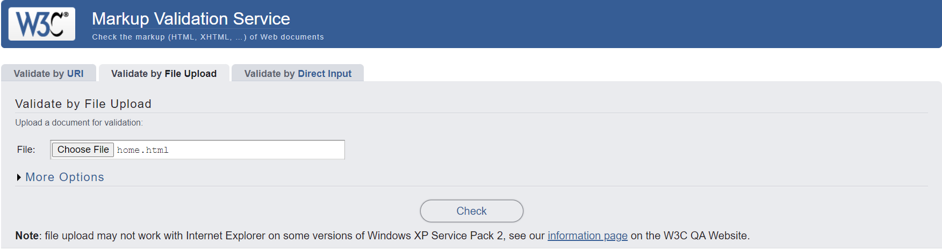

(Fig 1.01)

**After Checking**

(1) Error: Stray end tag div.

There is an extra </div> tag without a corresponding opening <div> tag is what the error notice refers to as in the HTML code. The issue was fixed by examining the code around line 127 and removing the unnecessary </div> tag to restore proper HTML structure.

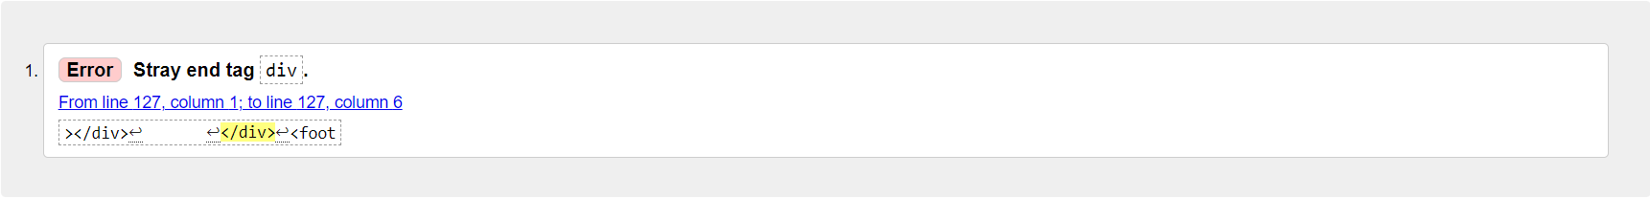

(Fig 1.02)

**After Fixing the error**

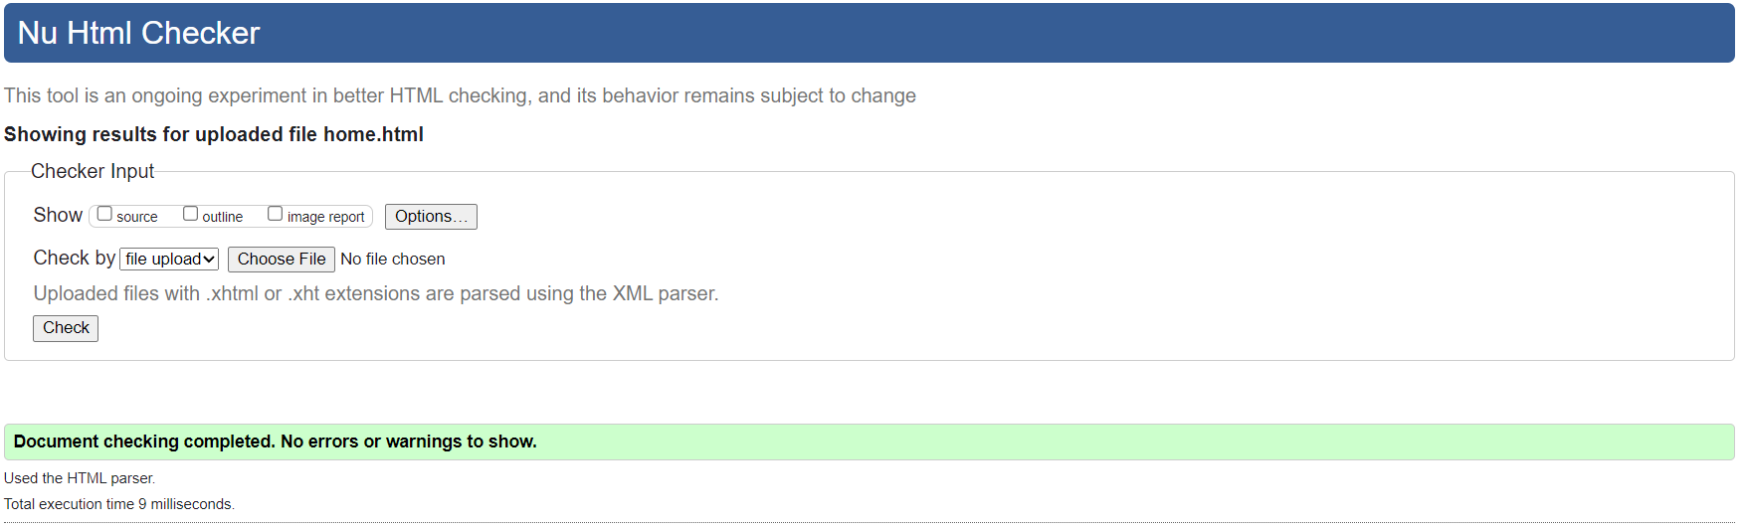

(Fig 1.04)

**camping_equipment.html**

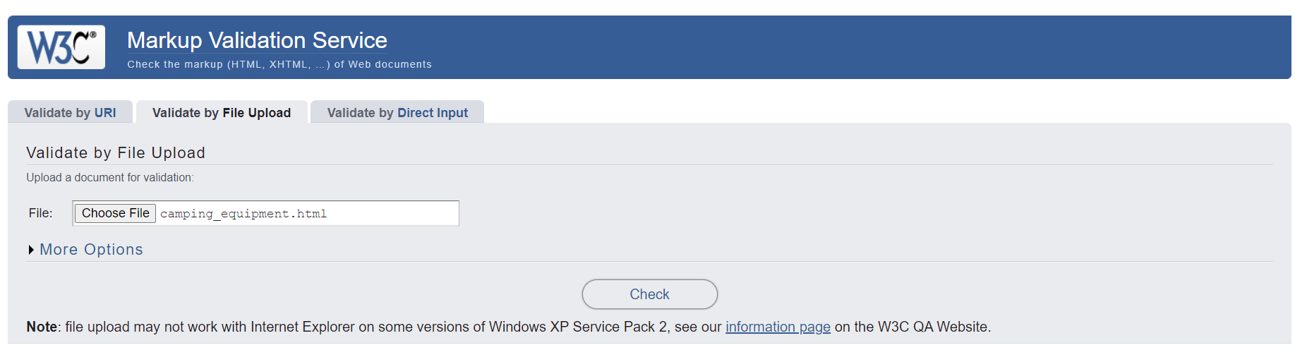

(Fig 1.05)

**After Checking**

**(1) Error The element** button **must not appear as a descendant of the (**a) **element**

This error occurs because there is a (button) element inside a (a) element. It is appropriate to use the (button) element inside the (a) element since their actions can overlap. This error was fixed by replacing the (button) element with a normal text.

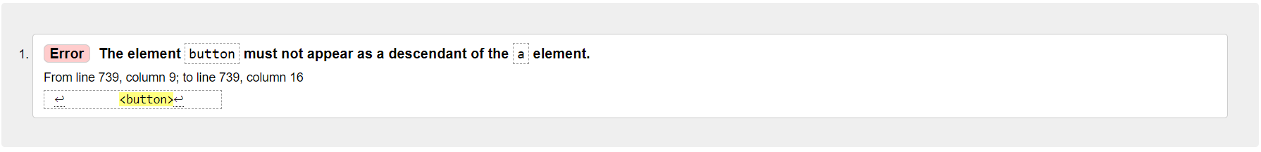

(Fig 1.06)

**After fixing the error**

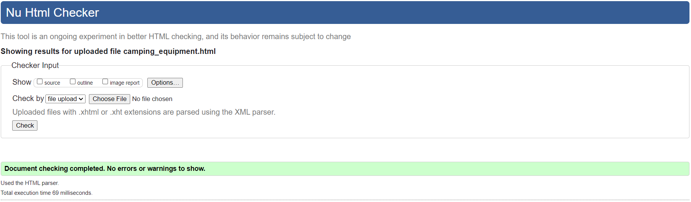(Fig 1.07)

**furniture.html**

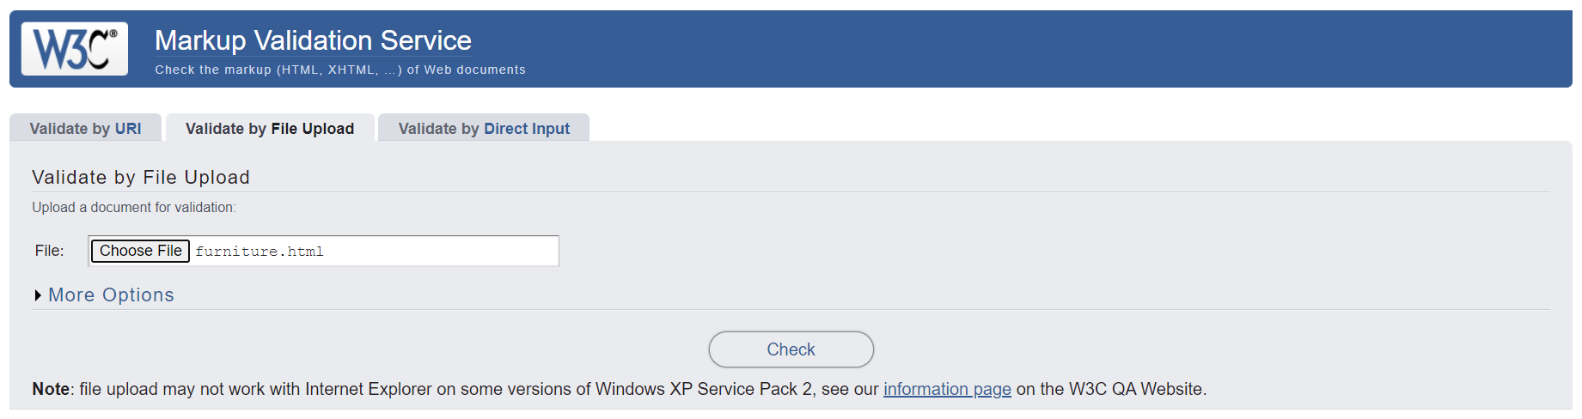

(Fig 1.08)

**After Checking**

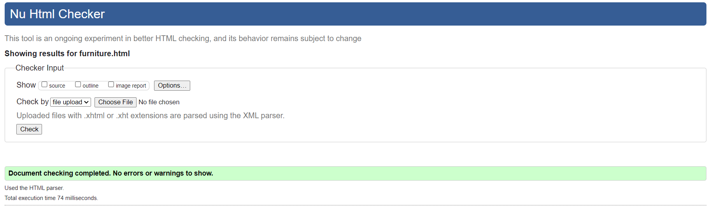

(Fig 1.09)

There are no errors in furniture.html file.

**cart.html**

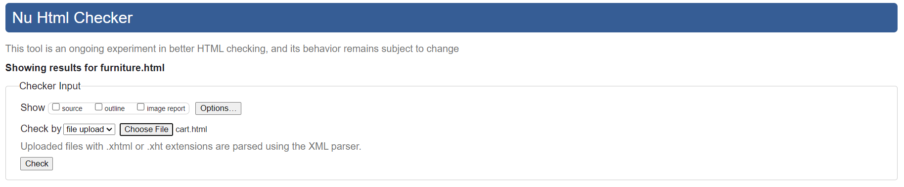

(Fig 1.10)

**After Checking**

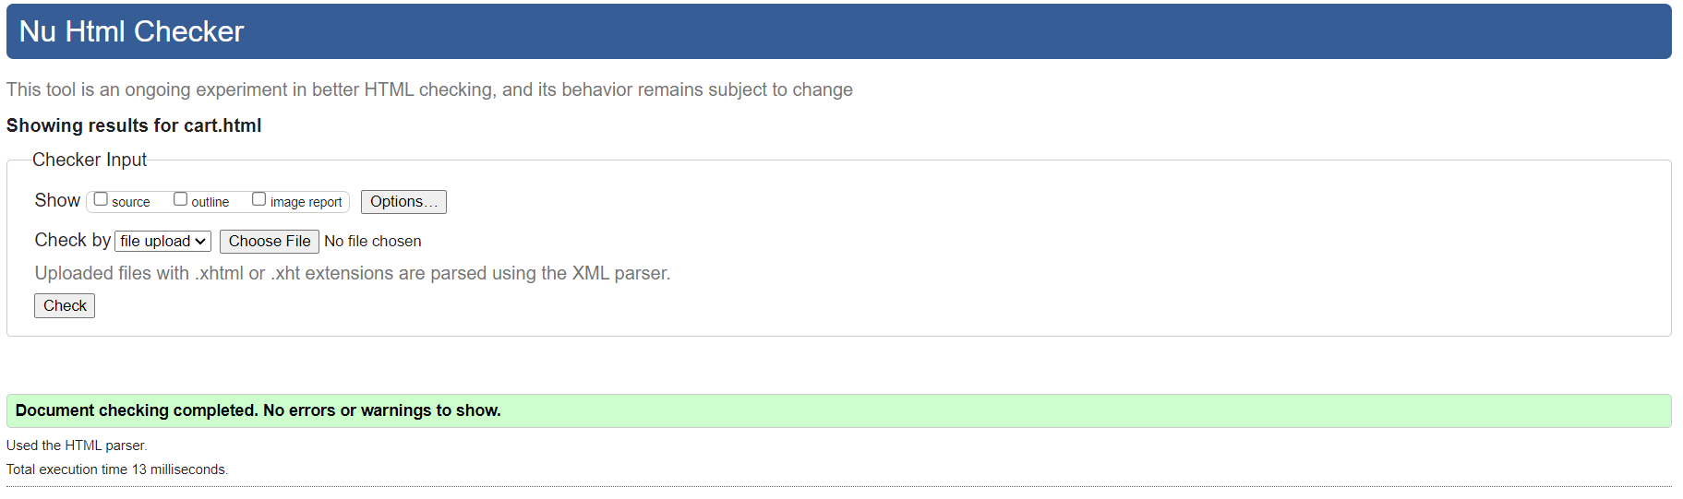

(Fig 1.11)

There are no errors in cart.html file.

**reviews.html**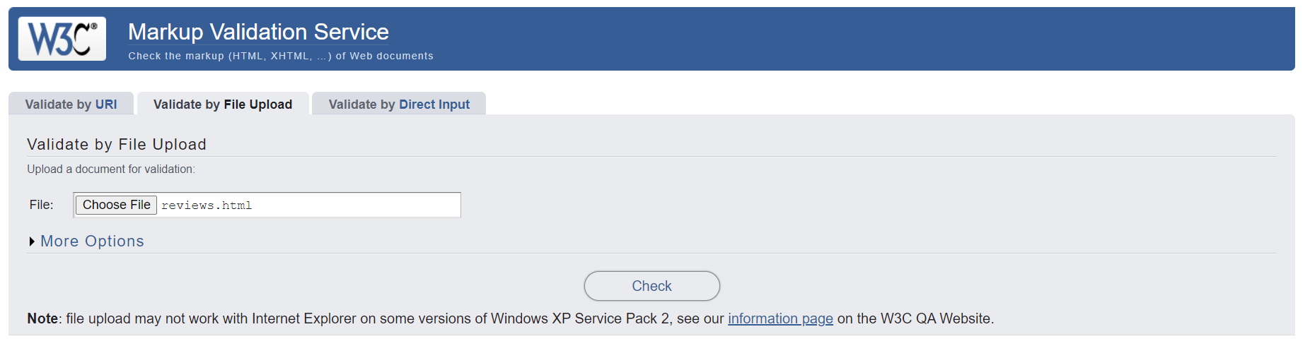

(Fig 1.13

**After Checking**

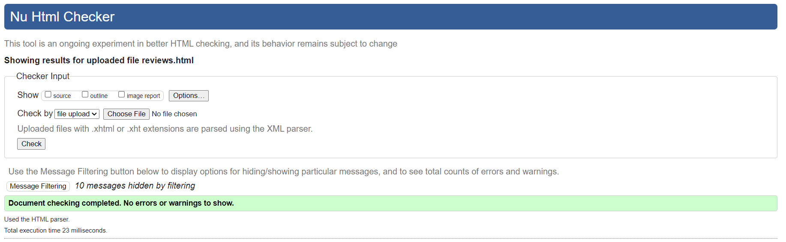

(Fig 1.14)

CSS

CSS file is also tested using CSS Validation Service as shown in the Fig 1.15 to find out possible errors within the code.

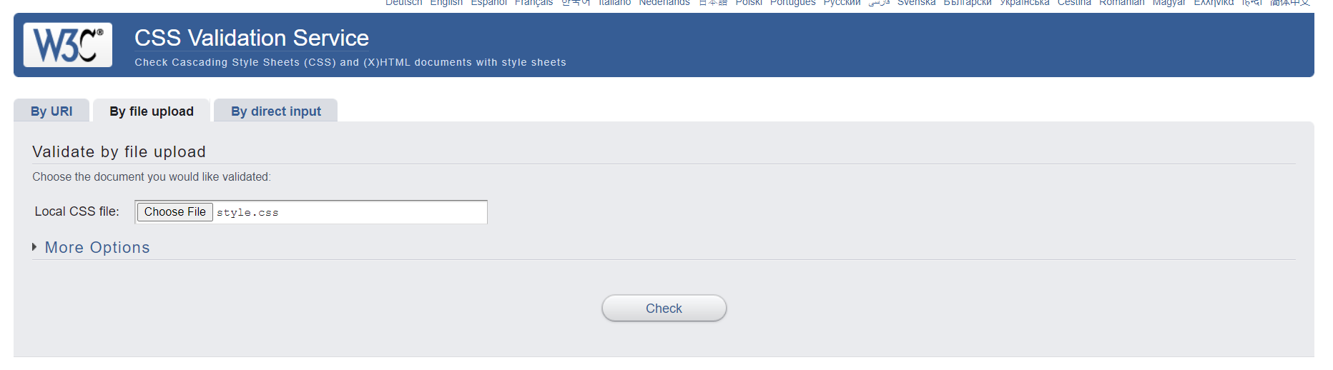

(Fig 1.15)

**After Checking**

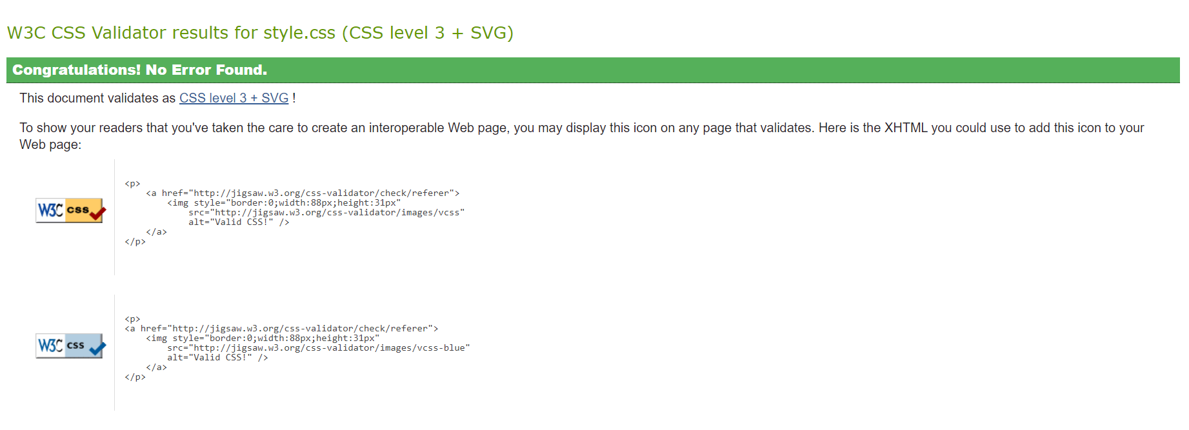

(Fig 1.16)

There is no error in styles.css

## Accessibility using a screen reader

Accessibility is making the developed website to be able to easily use by people with disabilities. Though many people think it is only for people with disabilities, making website with convenient accessibility also benefits other groups such as people who mainly use mobile devices or those with slow internet connections. (MDN_contributors, 2023)

When developing websites, it is critical to ensure that they are accessible for people with visual problems who use screen readers. It involves applying the proper coding for information, describing images, and ensuring that products can be effortlessly selected or tapped. Additionally, specific labels can be provided to page elements that change. Choosing readable fonts, contrast between colors, and text alternatives in multimedia improves accessibility. Testing with screen readers on frequently is essential for recognizing and fixing issues.

**Using screen reader on home page**

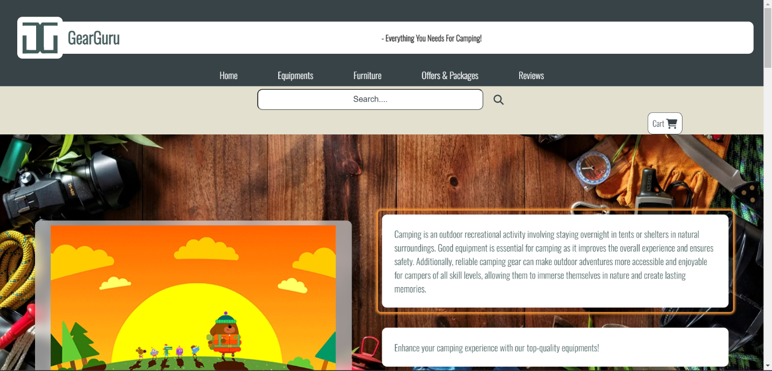

(Fig 1.17)

People with disabilities can easily regonized the texts just by clicking on any text they want to know. After clicking, the screen reader will read out loud until the end of the text.

**Using screen reader on equipment page**

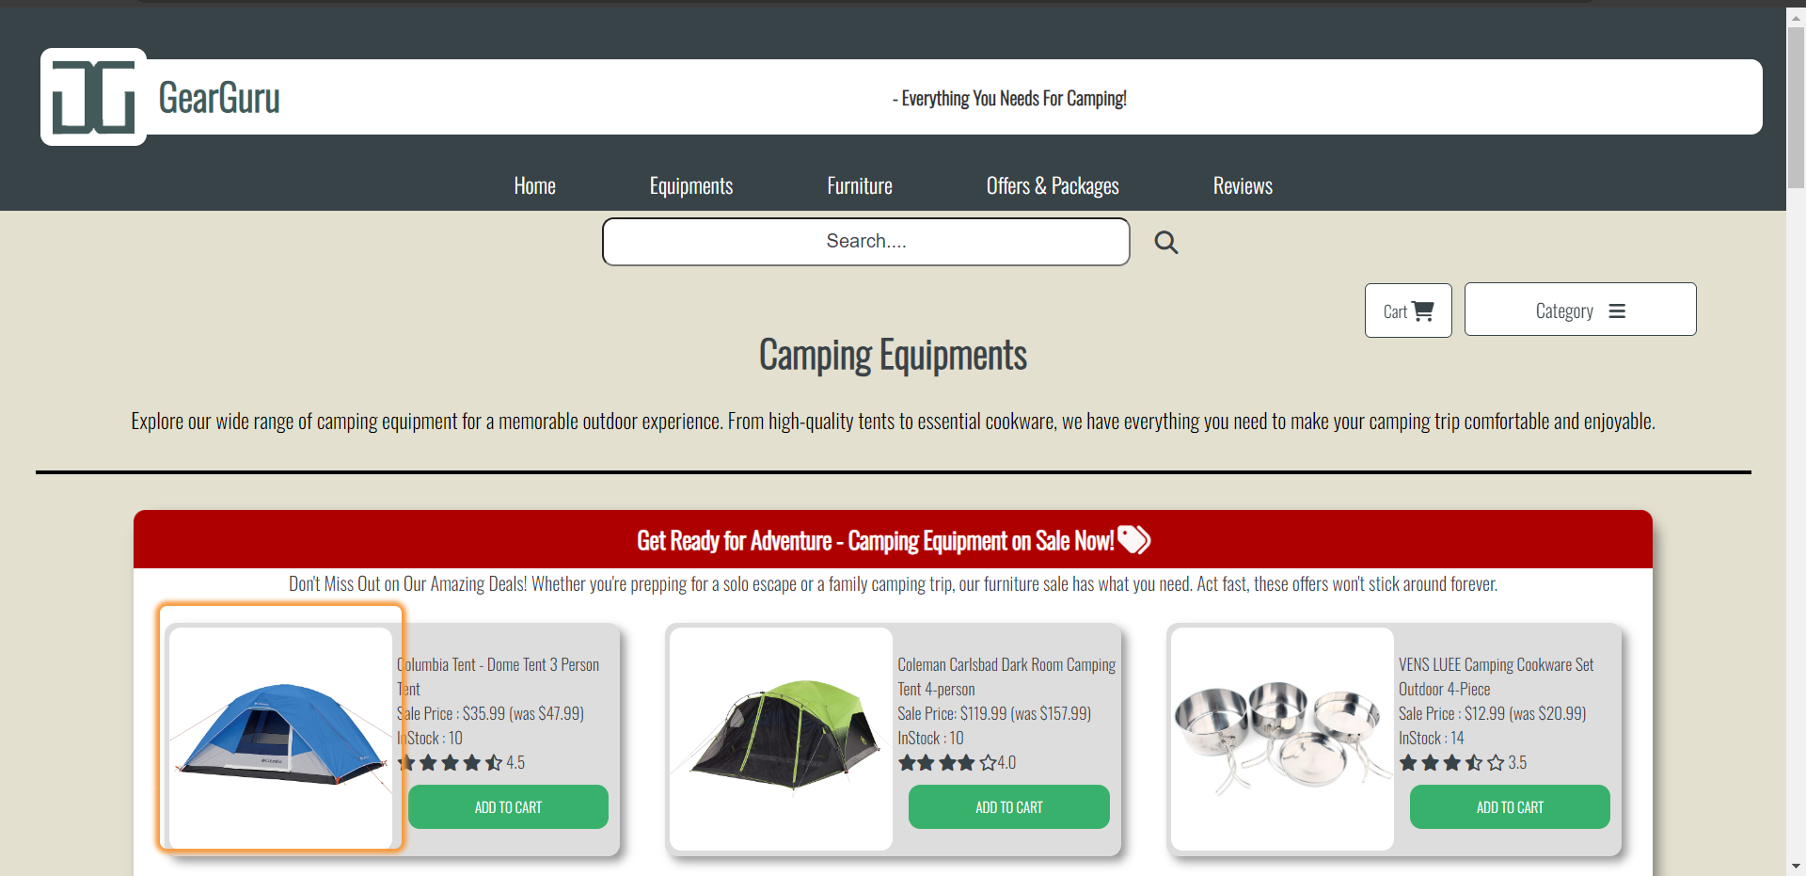

(Fig 1.18)

Screen reader will read out the alt name of the image when click on it as shown in (Fig 1.18). Making it easier for the disabled users to regonize items.

**Using screen reader on furniture page**

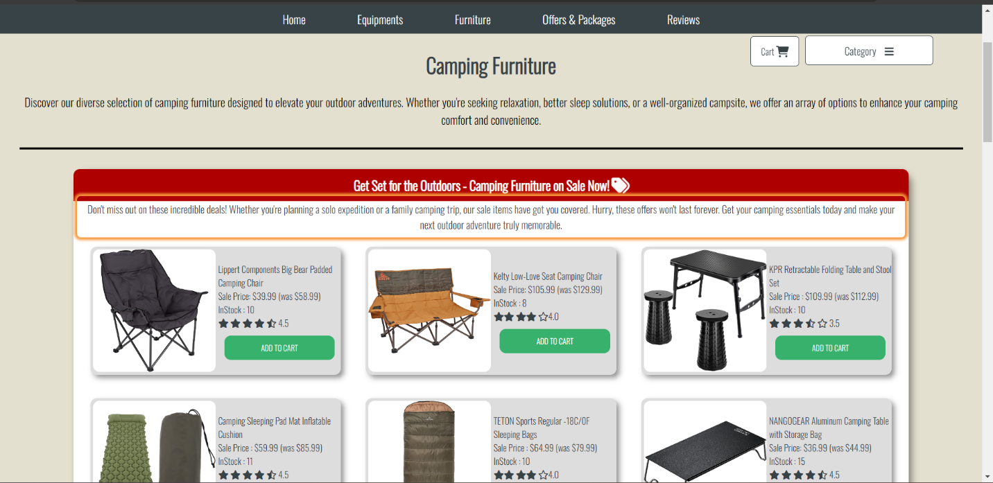

(Fig 1.19)

**Using screen reader on cart page**

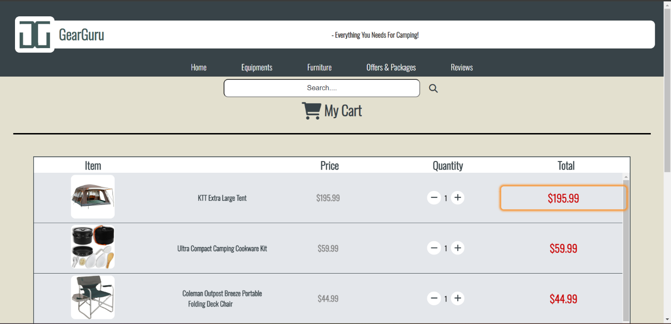

(Fig 1.20)

**Using screen reader in Offesr & Packages page**

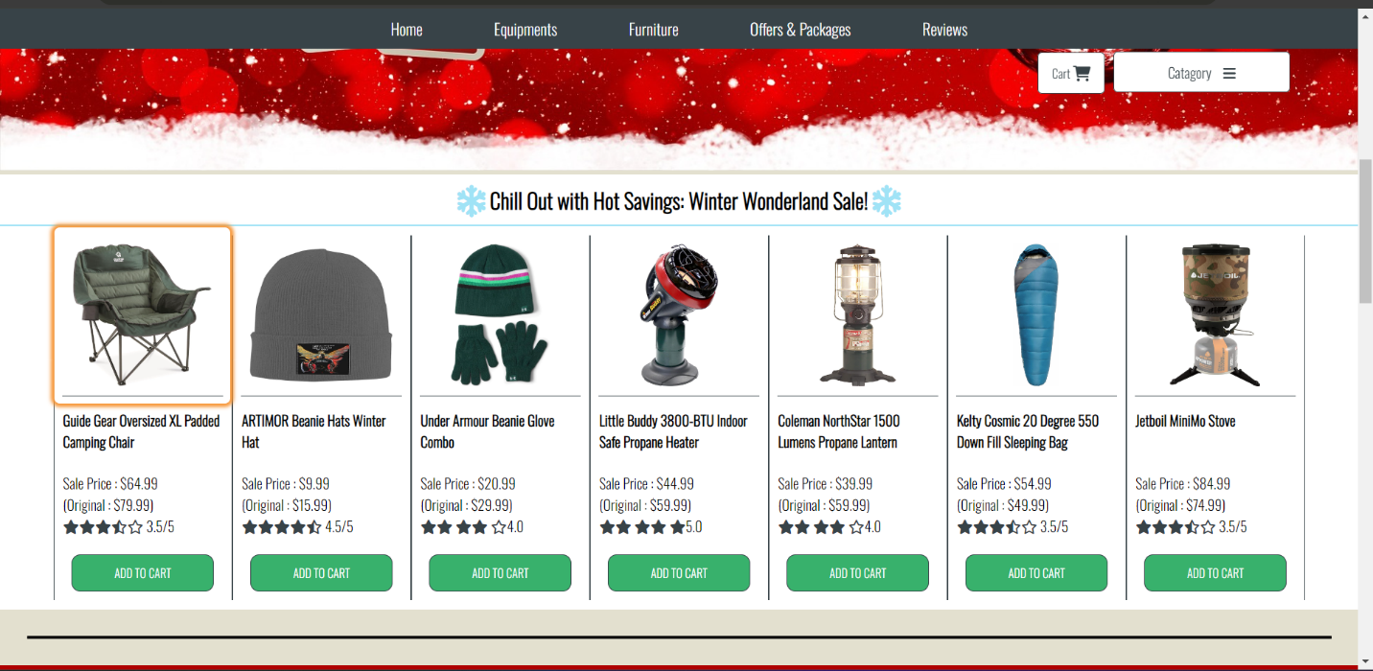

(Fig 1.21)

As shown in (Fig 1.21), screen reader will read out the item name for the disabled users.

**Using screen reader on Reviews page**

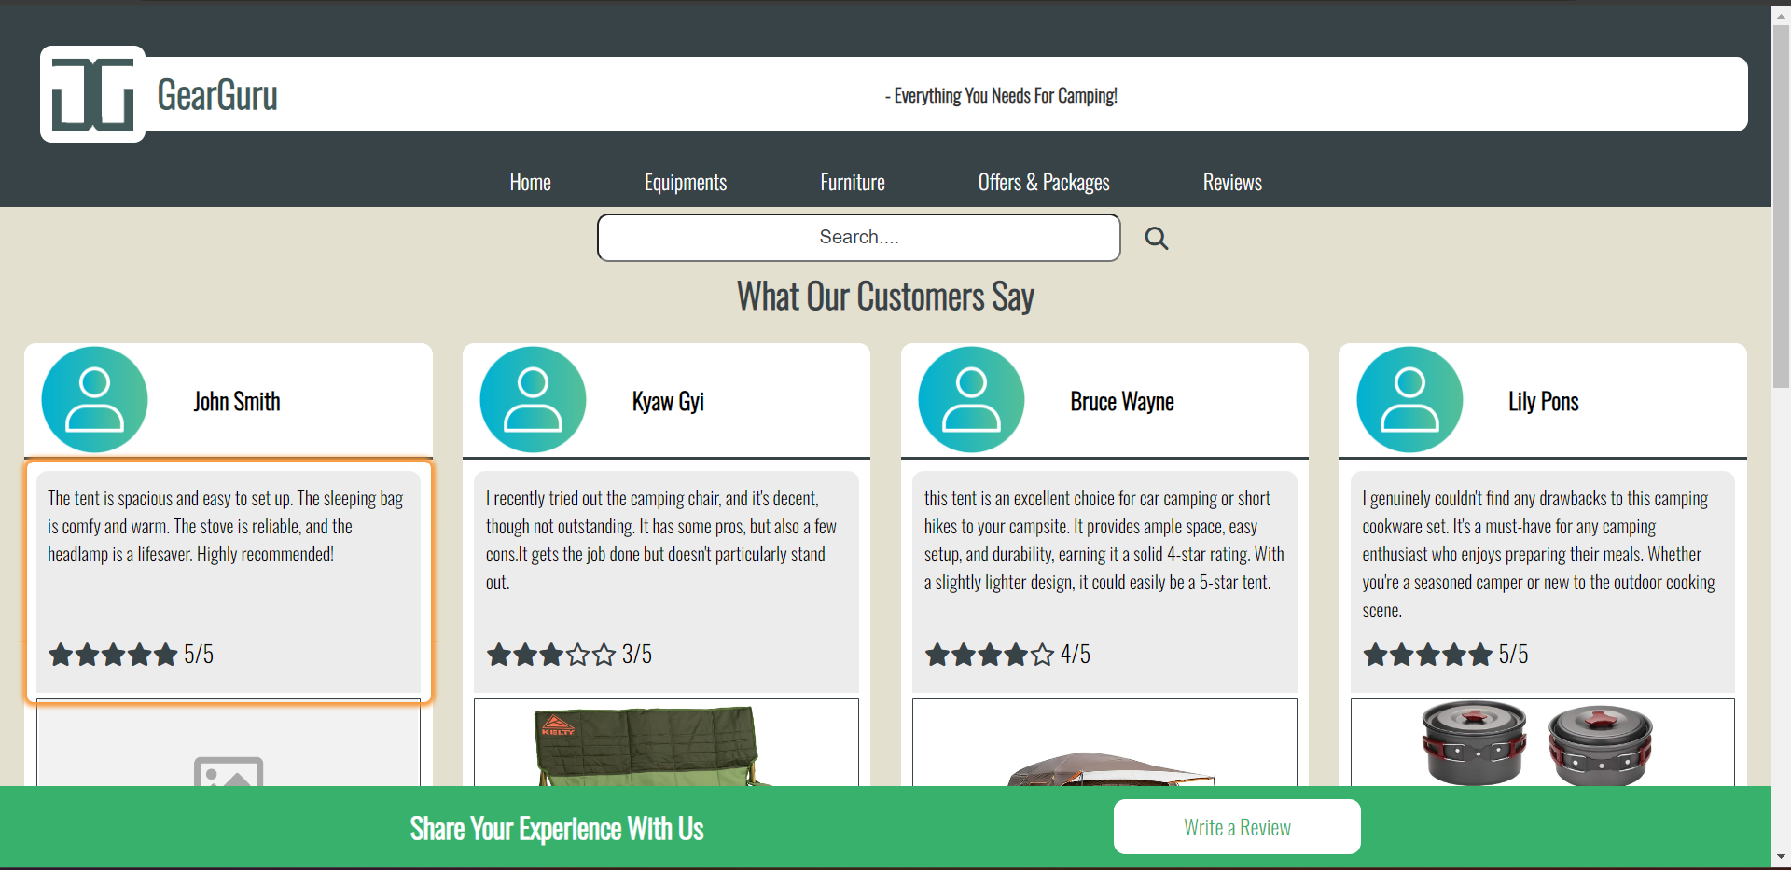

(Fig 1.22)

Screen reader will read the review text for the users with difficulties for small texts.

## How the website works for disabled Users

Responsive designs are implemented to each page of the website to make sure that the website smoothly adapts to devices and screen sizes. It can guarantee that disabled users who rely on various devices can access and operate the website easily.

Moreover, alternative text for all images features on the website are provided. The alt text can serve as descriptive text for the images, which make the uses with visual disabilities to easily understand the content of images using screen reader.

Additionally, careful consideration to color contrast is given throughout the website. Ensuring that text and essential elements stand out clearly against the background, enhancing the overall user experience for individuals with varying visual abilities.

## Testing the website on two browsers

The website is tested on two different browsers, **Chrome** (Version 116.0.5845.188) and **Microsoft Edge** (Version 117.0.2045.41). The scroll bar, at the right side of each browser, of Microsoft Edge browser is slighter smaller than the scroll bar of Chrome. And the Microsoft Edge browser add a little margin at the left and right side when displaying the website. Hence, slighting effecting the difference between width of the website. Other than that, there is no differences.

**Using Chrome for Home Page**

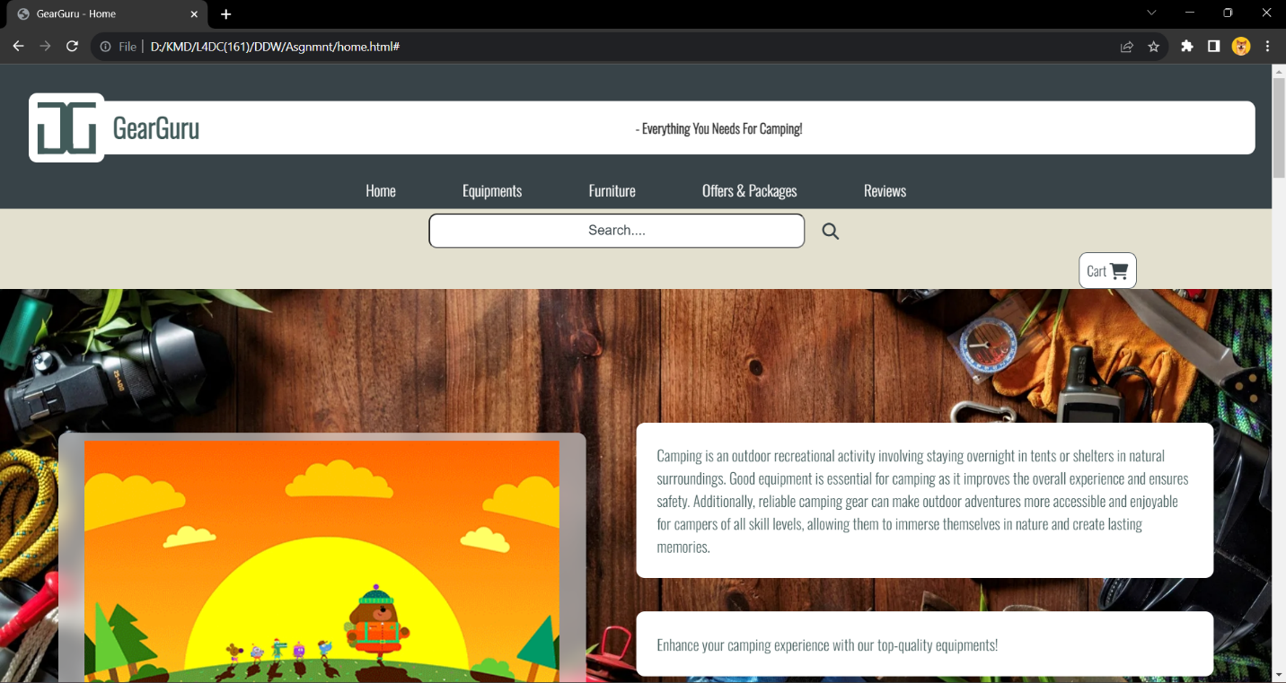

**Using Microsoft Edge for Home Page**

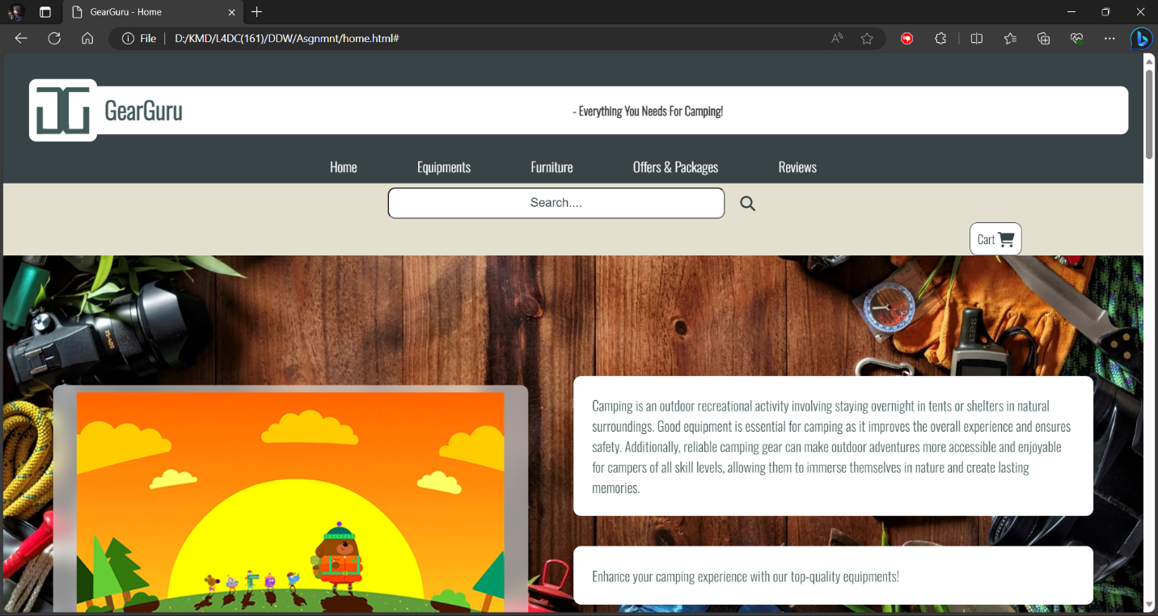

**Using Chrome for Equipment Page**

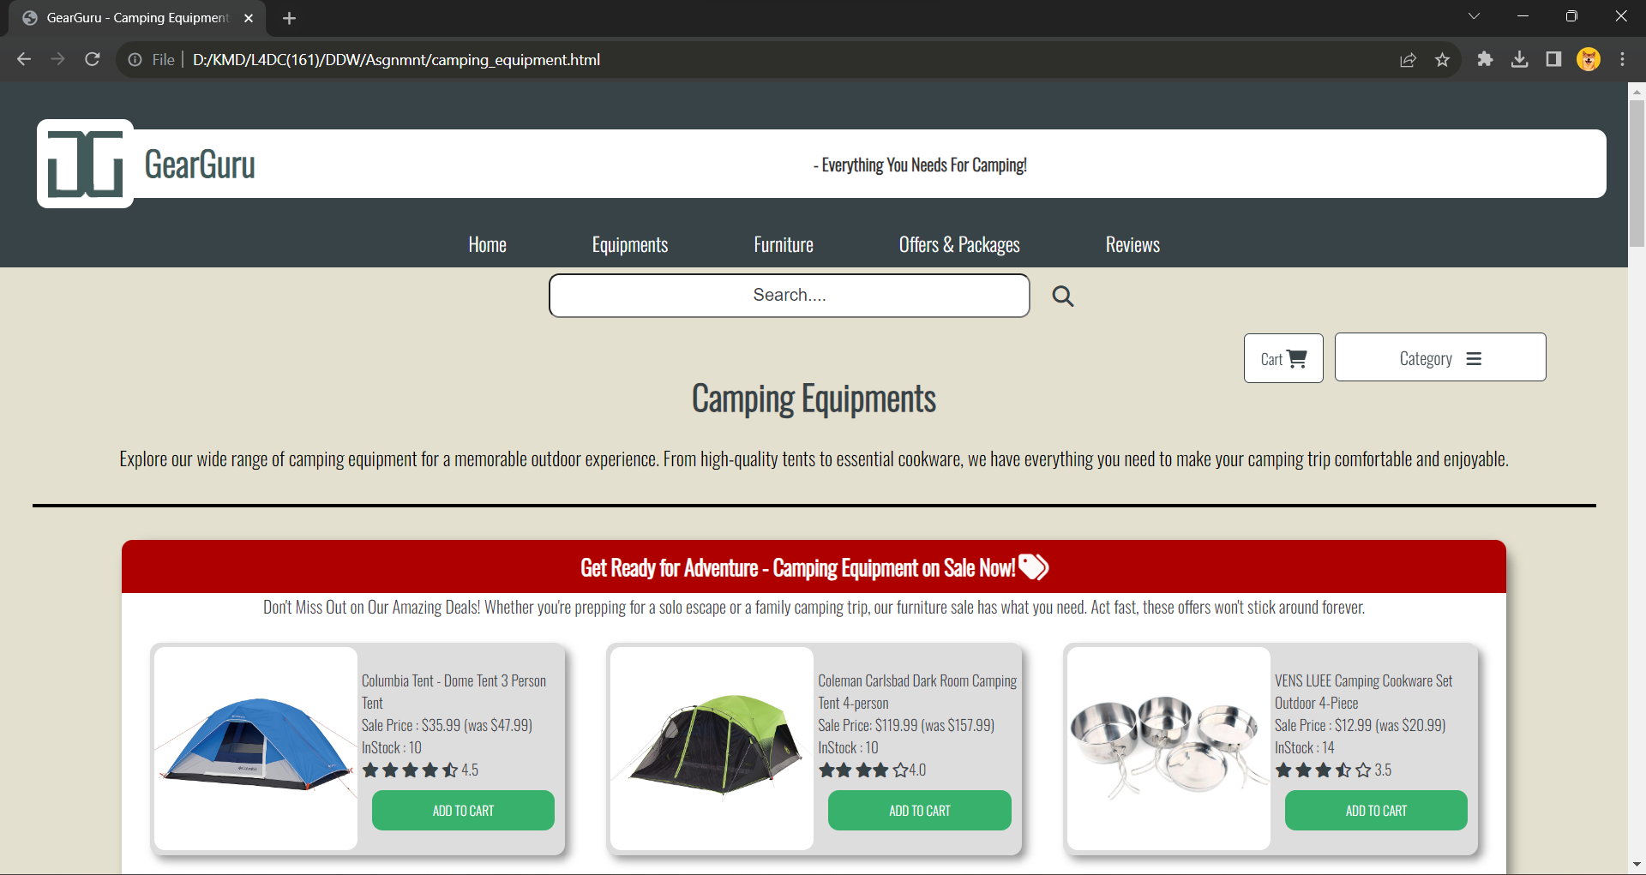

**Using Microsoft Edge for Equipment Page**

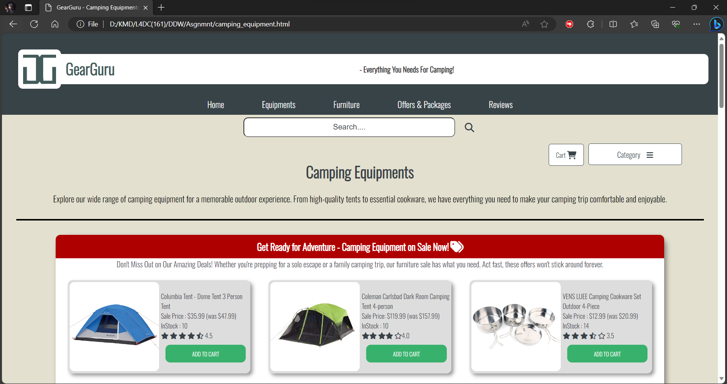

**Using Chrome for Furniture Page**

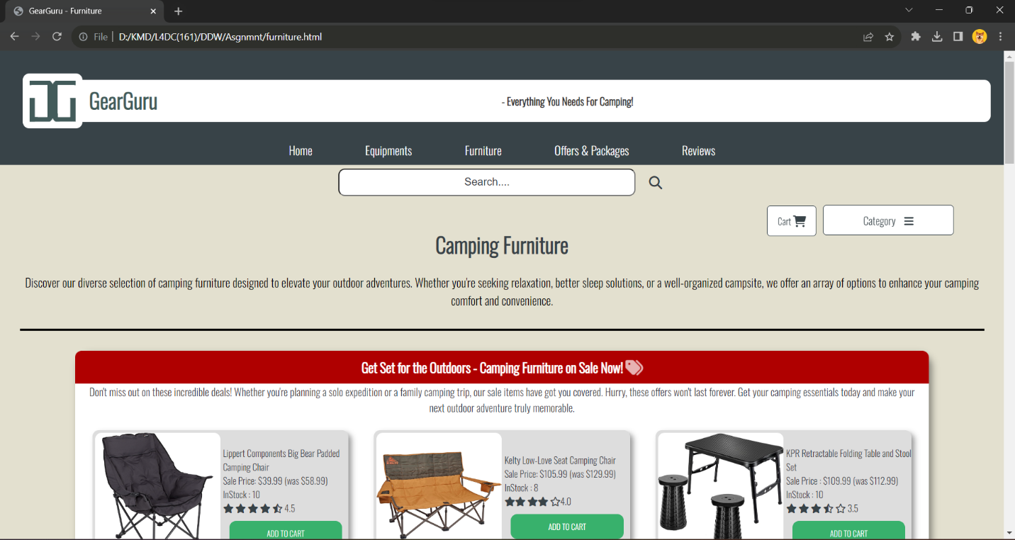

**Using Microsoft Edge for Furniture Page**

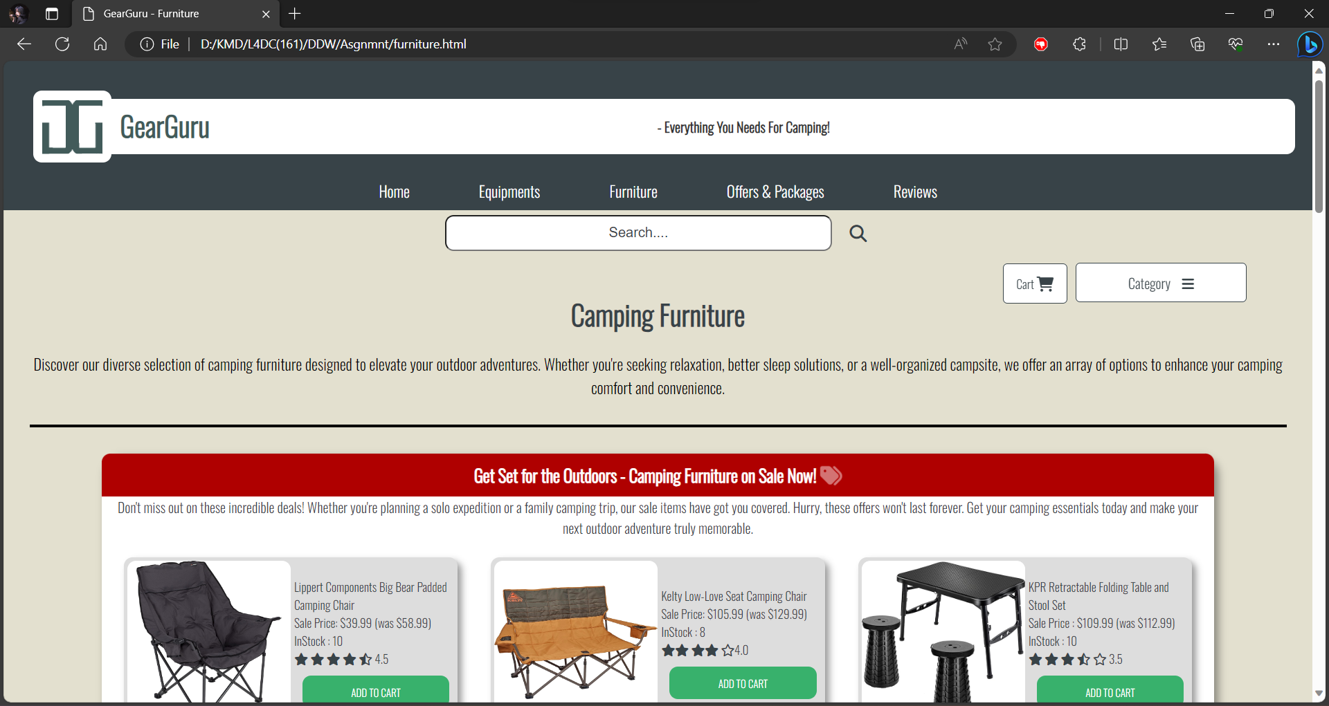

**Using Chrome for Offers & Packages Page**

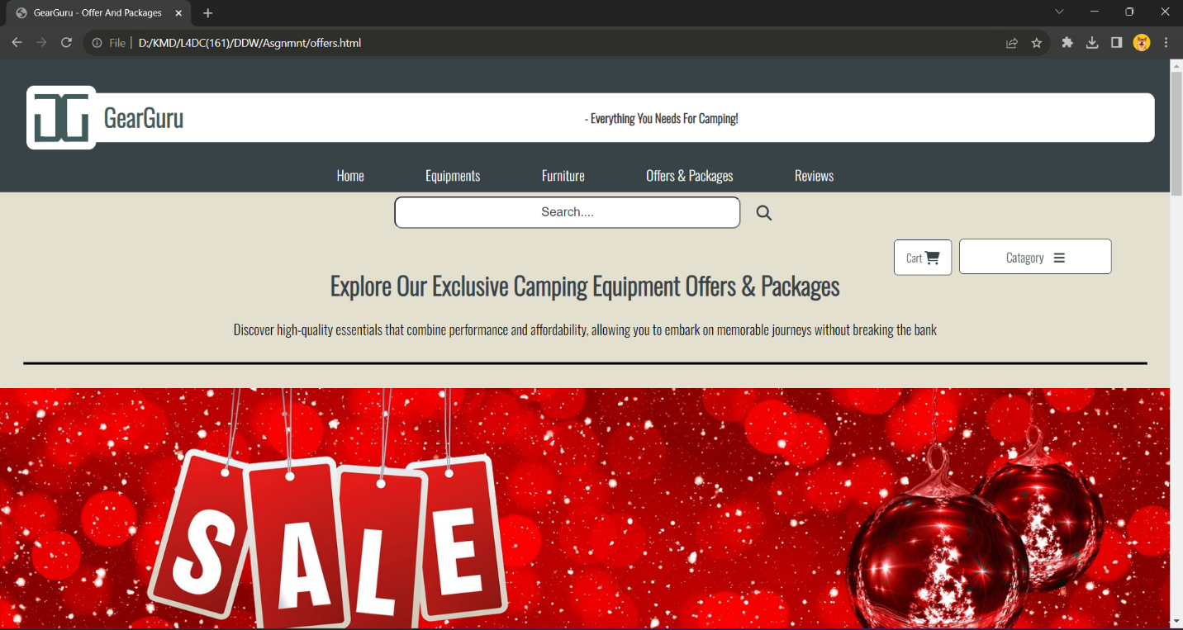

**Using Microsoft Edge for Offers & Packages Page**

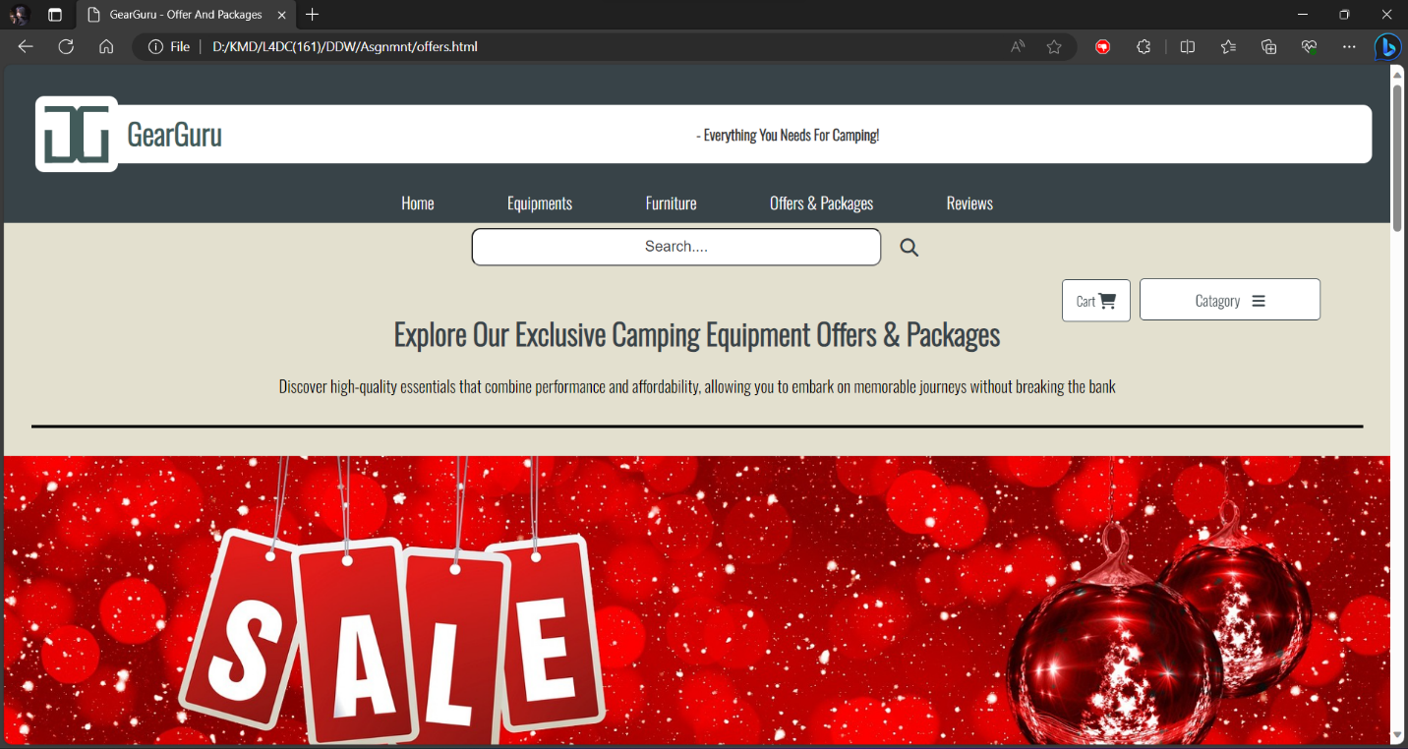

**Using Chrome for Cart Page**

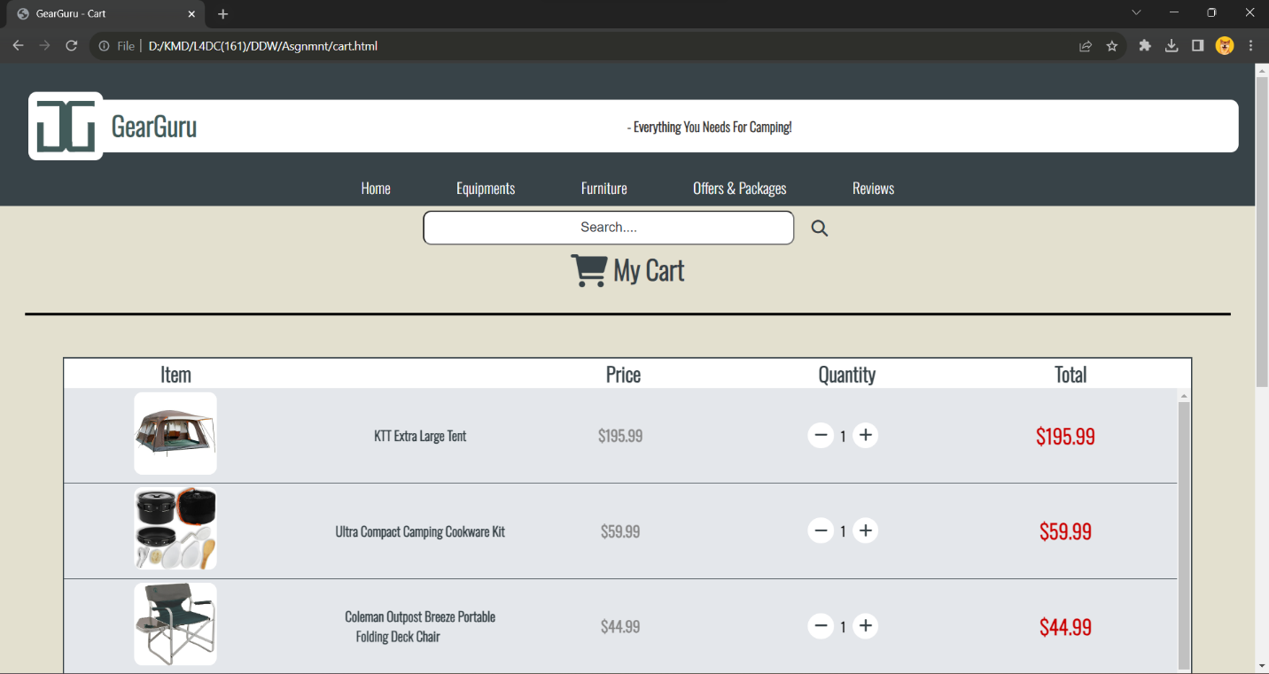

**Using Microsoft Edge for Cart Page**

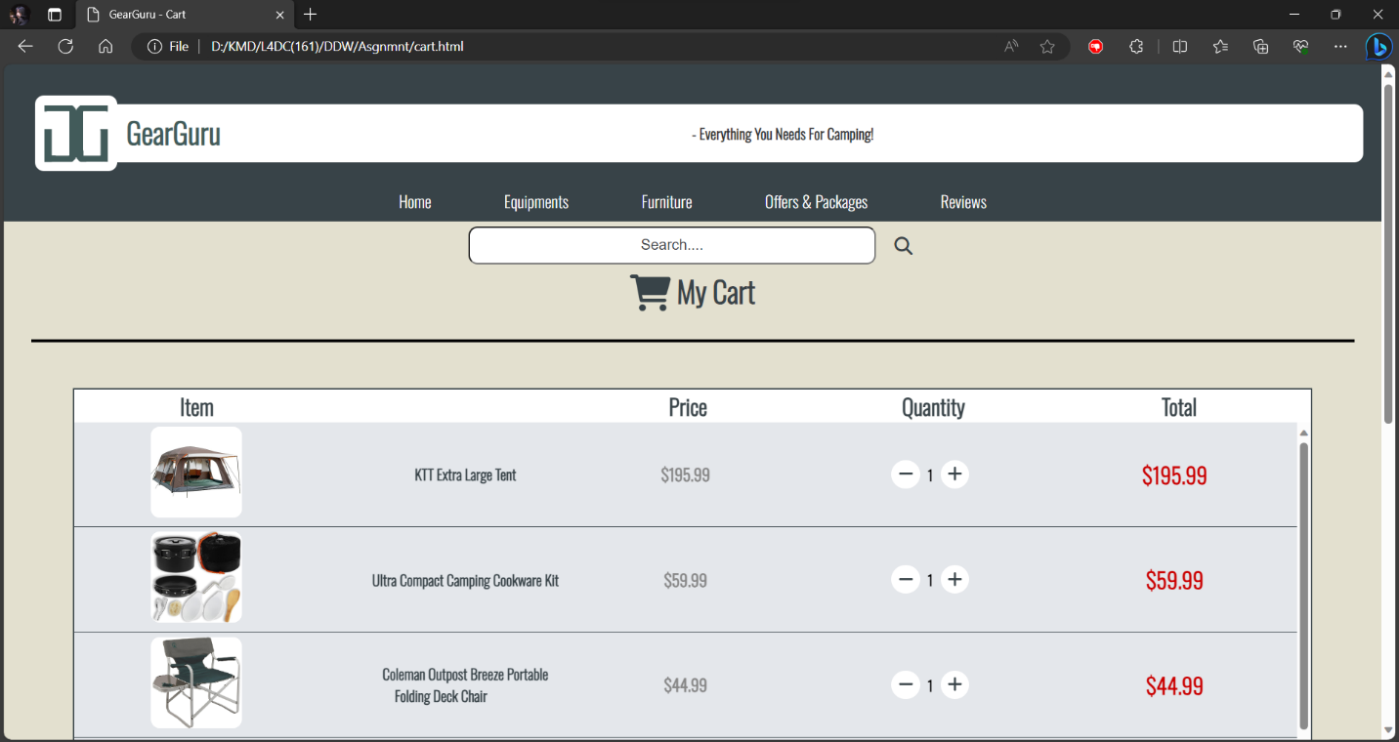

**Using Chrome for Review Page**

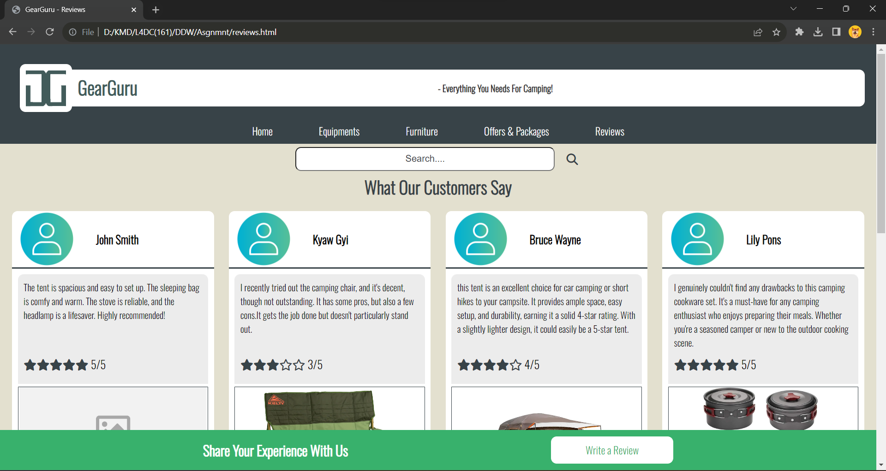

**Using Microsoft Edge for Review Page**

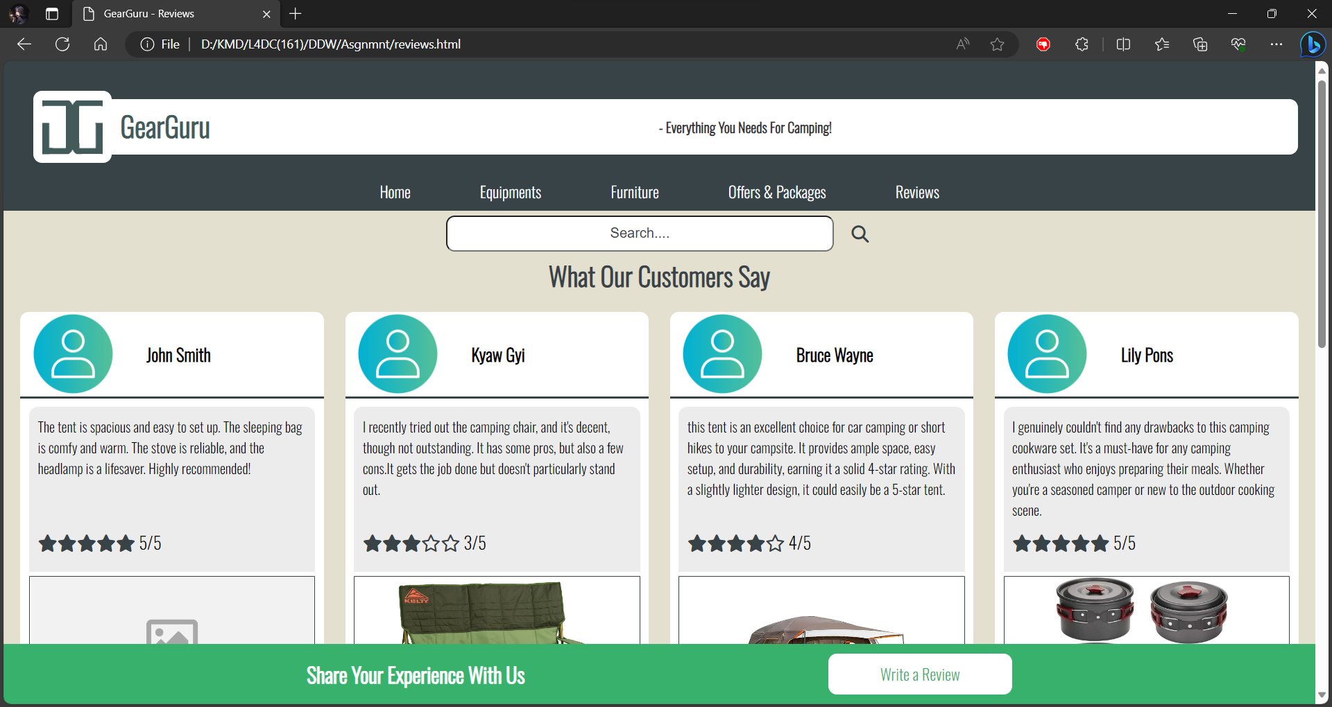

## Test Report

The goal of this test report is to evaluate the Retail Camping Company (RCC) website's HTML/CSS code validation, accessibility for disabled users, and cross-browser compatibility. The **W3C** validation service was used to validate the HTML and CSS code. Several non-compliant features were discovered and fixed to guarantee that the code complied to web standards. A screen reader was used to evaluate the website's accessibility. The site was found to be fairly accessible, due to **proper headers**, **alt text for images**, and the usage of logical HTML elements. The website was tested on both **Chrome** and **Microsoft Edge**, two different web browsers. There are only very little differences in **the website's width** due to **the scroll bar size difference** of the browsers and Microsoft Edge adding **a little bit margin**.

During the testing using **W3C** validation service checker, “**stray end tag div**” error in home page and the error where the **(button)** element was used in **(a)** element in equipment page. To debug the “stray end tag div” error in home page, the excess **</div>** tag was identified and deleted from the code. To debug the error in equipment page, the **(label)** element was deleted and use only the **(a)** element. Other than those, there are no more errors in the website.

## The role of the W3C

The **W3C** offers a free service called the Markup Validator that assists in validating Web content. The majority of Web content is created using markup languages like HTML or XHTML. These languages are defined by technical specifications, which frequently include a formal grammar (and vocabulary) that is machine-readable. The Markup Validator validates documents by comparing them to certain restrictions, which is a process known as validation. (W3C, 2023)

**W3C** validator will check the html page and identify errors that can occur during testing and show it to users. Thus making the website smoother and perform better.

**Task 4**

# Task-4 Critical Evaluation

## (a) Three Different Plugins

**<object>** element was used in home page to display a GIF. Using the **<object>** element to display a GIF is a suitable choice for adding animated visual content for the website. GIFs are widely supported across browsers and are efficient for showcasing short animations or visual highlights. GIFs auto-play by default, so users don't need to click on them to start the animation. This can grab users' attention and draw them into website content.

**<iframe>** element was used in home page to display the company location and in equipment page and furniture to display YouTube videos. Embedding YouTube videos using an **<iframe>** element allows the website to use high-quality video content without needing large hosting resources. By adding YouTube videos, they provide a dynamic and visual element to the website.

**<embed>** element was used in offers & packages page to display an image. The **<embed>** element can be used for displaying multiple types of content that included animated graphics or multimedia elements that HTML does not support natively.

## (b) Two Web Application Development Tools

**VSCode** was used for developing and writing the codes for the website and **W3C** validation service checker was used for debugging errors of the website.

**Visual Studio Code (VSCode)**, is free and cross-platform making it accessible regardless of the operating system. It is excellent at creating and modifying code.

**W3C** validation service checker tool is useful for fast checking code for compliance with web standards. For developers who are new to web development, they are readily available and useful. It became a lot easier to identify the errors after using the W3C validation service checker.

## (c) Two Business Benefit to RCC of using web services

**Expanded Customer Reach:**

RCC can broaden its market reach beyond the limits of its physical shop by using online platform. Through the website online presence, RCC could connect with customers in many different regions, potentially **expanding both its customer base and market share**.

**Convenient Transaction Processing:**

Web services simplify transactions as RCC adapts to accepting payments and processing orders online. transactions became more easy and less time consuming to process. Customers can shop more conveniently and more smoothly by adding products to their carts, making safe payments, and checking their orders. Because of the convenience in shopping, **RCC will expand their customer base enormously**.

## (d) Improvements for further development

**(Multiple Language Support)** Adding multi-language support to the website to expand the customer base internationally. Allow customers to select their own preferred language, and make product descriptions and further details available in different languages. By adding multiple language options to the RCC website, customers whose first language is not English will be more please to explore the website. Therefore, resulting in **increase of customer’s satisfaction and customers across the world.**

**(Using more advanced Technology)** To Improve the website, more advanced coding technology such as JavaScript should be used. JavaScript allows to create dynamic and interactive web sites. Customers are more likely to stay on a website longer and have a better overall impression when they encounter an enjoyable and engaging interface. **Customer satisfaction and loyalty may improve as a result.**

# References

Jordan. (2013, June 26). *The Importance of W3C Standards*. Retrieved from Bop Design: https://www.bopdesign.com/bop-blog/2013/06/the-importance-of-w3c-standards/#:~:text=Created%20in%201994%2C%20W3C%20is,ensure%20its%20long%2Dterm%20growth.

MDN_contributors. (2023, July 3). *What is accessibility?* Retrieved from Mozilla: https://developer.mozilla.org/en-US/docs/Learn/Accessibility/What_is_accessibility#see_also

Microsoft. (2022). *Complete guide to Narrator*. Retrieved from Microsoft Support: https://support.microsoft.com/en-us/windows/complete-guide-to-narrator-e4397a0d-ef4f-b386-d8ae-c172f109bdb1#:~:text=Narrator%20is%20a%20screen%2Dreading,about%20what's%20new%20in%20Narrator.

Nick. (2015, October 14). *ProWebmasters*. Retrieved from StackExchange: https://webmasters.stackexchange.com/questions/14324/font-displays-differently-in-firefox-vs-chrome

W3C. (2023). *About The W3C Markup Validation Service*. Retrieved from W3C: https://validator.w3.org/about.html

W3Schools. (2023). *CSS Introduction*. Retrieved from W3Schools: https://www.w3schools.com/css/css_intro.asp

# Candidate checklist

Please use the following checklist to ensure that your work is ready for submission.

Have you read the NCC Education documents 'What is Academic Misconduct? Guidance for Candidates' and 'Avoiding Plagiarism and Collusion: Guidance for Candidates' and ensured that you have acknowledge all the sources that you have used in your work?



Have you completed the 'Statement and Confirmation of Own Work' form and attached it to your assignment? You must do this.



Have you ensured that your work has not gone over or under the recommended word count by more than 10%?



Have you ensured that your work does not contain viruses and can be run directly?

